

**SOFTWARE REQUIREMENT SPECIFICATION (SRS) SIGN-OFF**

**Authorization Memorandum**

This form is to sign-off completion of the Requirement Phase for **CAMPUS MANAGEMENT SOFTWARE AT WORLD SKILL CENTER (WSC).**

World Skill Centre (WSC) acknowledges receipt of the deliverable as part of the Requirement Phase through the submission of this document.

|  |  |
| --- | --- |
| **MODULE NAME** | **Examination Module** |

| **VERSION HISTORY** | | | |
| --- | --- | --- | --- |
| **Version** | **Author** | **Date** | **Changes** |
|  |  |  |  |
|  |  |  |  |

**WSC AUTHORITY NAME AND**  **SIGNATURE**

**SOUL AUTHORITY NAME AND**  **SIGNATURE**



Pages 1 of 59

**Sustainable Outreach And Universal**

**Leadership (SOUL) Limited**

**Software Requirement Specification (SRS)**

**Of**

**Examination module**

For Implementation of

**Campus Management Software**

at

**World Skill Center (WSC)**

**Table of Content**

A. Abstract 3

B. Introduction 3

C. Definition, Acronyms and Abbreviations 3

D. Overview of the Document 3

E. Scope of Education Module 4

F. WSC Student Examination Process Flow 5

G. Process Flow Description 5

H. List of Screens and Their Descriptions 6

I. Examination 9

1. Examination Master 9

1.1 Exam Type 9

1.2 Assessment Criteria 10

1.3 Grading Scale 11

1.4 Student Exam Block Criteria 13

2. Examination Transaction Screen 14

2.1. Exam Declaration 14

2.2. Examination Process 19

2.3. Exam Evaluation Plan 26

2.4. Exam Paper Setting 30

2.5. Criteria Wise Evaluation 33

2.6. Criteria Wise Evaluation Tool 35

2.7. Continuous Evaluation 37

2.8. Continuous Evaluation Tool 40

2.9. Final Exam Result 42

2.10. Final Result Declaration Tool 45

2.11. Module Wise Pass Percentage 47

2.12. Course Wise Pass Percentage 49

2.13. Back Paper Tracking 50

2.14. Cumulative Marksheet 52

2.15. Cumulative Marksheet Tool 55

# Abstract

Software Requirements Gathering is one of the first phases of system development. This phase results in the Software Requirements Specification (SRS) document, which must contain a complete, concise, high-quality description of the system being considered.

# Introduction

The World Skill Center (WSC) is a premier advanced skill training institute established by the Government of Odisha, Skill Development and Technical Education Department, through the Odisha Skill Development Authority (OSDA). The WSC will impart advanced skill training in eight trades from engineering and service sectors. WSC caters primarily to induct the best talent from ITIs and Polytechnics and train them to become globally employable in emerging areas such as "Industry 4.0". WSC is housed in a state-of-the-art, 18-storey, air-conditioned building with nearly half a million square feet of space in the heart of capital city of Bhubaneswar.

With the implementation of campus management software for WSC the goal is to streamline the operations and functions of the campus by integrating various processes, such as admissions, course registration, academic progress tracking, and financial management, HRMS, Procurement and Inventory management, etc into a unified system. The implementation also aims at providing a user-friendly interface for all stakeholders, making it easier for them to access the necessary information and complete their tasks with ease. The modules to be covered during the implementation of the software includes:

|  |  |
| --- | --- |
| Students Management Modules | Infrastructure Management |
| Academic System | Finance and Accounting System |
| Procurement & Inventory Management | Training and Placement |
| Human Resources Management System | Application Integration |

# Definition, Acronyms and Abbreviations

The following table explains the terms and abbreviations used in the document:

|  |  |
| --- | --- |
| **Abbreviation** | **Description** |
| SRS | Software Requirements Specification |
| SLCM | Student Life Cycle Management |
| R | Rename - When a field is Renamed |
| N | New - When a New field is Added |
| D | Delete - When an Existing field is Deleted |
| NA | Not Applicable |

# Overview of the Document

This requirement document provides a detailed overview of the functional requirements of a project. It serves as a communication tool between stakeholders, including developers, project managers, and end-users. The purpose of this requirement document is to define and document the project's objectives, scope, and expectations, and to ensure that all stakeholders have a clear understanding of what the project entails.

This document covers all the functional requirements of the **Examination module** of ERP Product. The ERP Examination module helps in organizing the entire education set-up, such as Student Database, Fee Structure, Trainer Information Assessment and Result Declaration and Cumulative Marksheet, Certificate Generation, etc.

# Scope of Education Module

* Courses and Subjects, Timetable preparation and management  ▪
* Class occurrence monitoring
* Class Attendance of students (Face recognition or any other automated mode).    ▪
* Results Analysis after declaration of results by WSC ▪
* Students Feedback mechanism on quality of teaching learning ▪ Internship, Training, Apprentice ▪
* Re-Admission Process after discontinuing in studies ▪
* Students Back paper tracking etc.
* Student Profile :Personal Information, Contact Details, Academic Details ▪
* Issue of Identity Card.  ▪
* Student Profile: Personal Information, Contact Details, Academic Details.
* Re-Admission Process after discontinuing in studies
* Issue of Identity Card
* Faculty Workload / Lesson Plan
* Rewards and achievements. 
* Biometric Attendance (Face recognition) ▪
* Hostel Management (Hostel seat allotment, attendance, fees etc) ▪
* Scholarships.  ▪
* Rewards and achievements.  ▪
* Students’ Evaluation/remarks of Faculty.  ▪
* Student Exams records of all 6 semesters ▪
* Parent Enquiry/Alert/Messaging Management.  ▪
* Messaging System  ▪
* Student Grievance System etc.

Following functionalities are covered in this SRS document:

* **Results Analysis after declaration of results by WSC ▪**
* **Students Back paper tracking etc.**
* **Students Exams records ▪**
* **Alert/Messaging Management. **

▪

# WSC Student Examination Process Flow

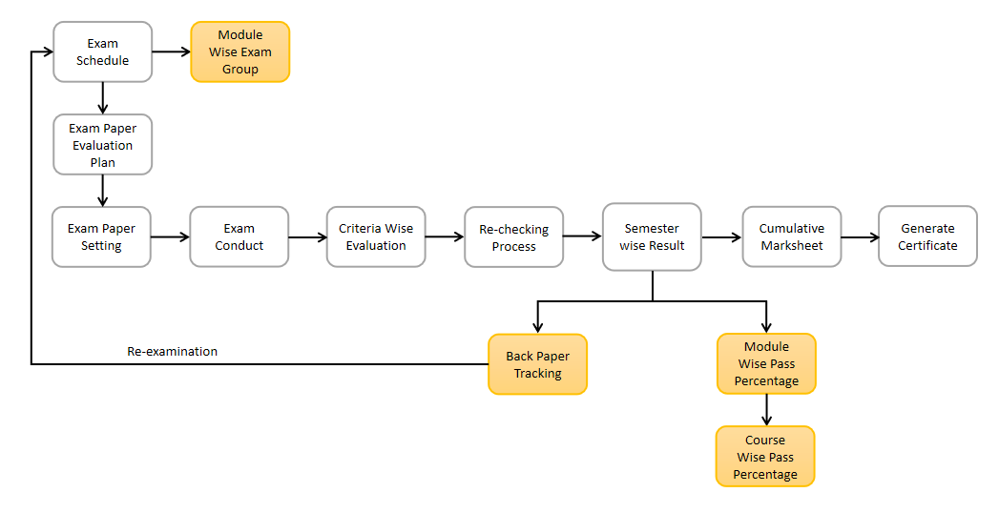

- No Change

- Gap Between Existing and WSC Process Flow

# Process Flow Description

**Exam Schedule**

The Exam Schedule will allow users to schedule an exam for various courses with respect to the academic year, Semesters, classes, assessment components, etc.

**Module Wise Exam Group**

Module Wise Exam Group will allow user to segregate each class students in to different groups for examination, It also creates the Attendance Sheet and score sheets for different groups w.r.t. particular class of different Modules.

**Exam Paper Evaluation Plan**

An Exam Evaluation Plan contains the list of paper setters and moderators for different modules of particular course semester.

**Exam Paper Setting**

The Exam Paper Setting is used to prepare paper setting schedules, paper sets and plan for paper setters and allow the trainers to attach their paper sets.

**Criteria Wise Evaluation**

Criteria Wise Evaluation allows you to do an evaluation for a particular assessment component of individual modules for students who are enrolled in a particular course.

**Rechecking Process**

Rechecking Process is used to re evaluate the assessment components of a particular module for individual students.

**Semester Wise Result**

Semester Wise Result Declaration is used to evaluate the final assessment of a student for a particular semester including all the assessment components of Students.

**Back Paper Tracking**

Back Paper Tracking is used to actively track and maintain history of the whole examination process of a student who has failed in one or more modules.

**Module Wise Pass Percentage**

Module wise Pass Percentage is used to calculate the percentage of students who have successful passed any particular module in any specific Academic Year.

**Course Wise Pass Percentage**

Course wise Pass Percentage is used to calculate the percentage of students who have successfully passed any particular course in any specific Academic Year.

**Cumulative Marksheet**

Cumulative Marksheet is a compilation of all the semesters with their grades in a single certificate. The Cumulative Marksheet will have a list of subjects, grades obtained and CGPA (Cumulative Grade Point Average). And also details of students, such as roll number, name, age and date of birth, program enrollment.

**Generate Certificate**

In the system, there are multiple screens to generate different types of certificates which are issued in the name of the student after course completion. The certificates that can be generated are Leaving Certificate, Provisional Certificate, Migration certificate, etc.

# List of Screens and Their Descriptions

The following tables list the pages used in the examination module :

|  |  |  |
| --- | --- | --- |
| **Sl no** | **Existing Application** **Screen Name** | **Description** |
| 1 | Exam Type | The Exam Type allows users to create and set values for a particular Exam Declaration which shall be beneficial to determining the type of examinations that are being conducted and can be evaluated on the basis of it. For example, an Exam Declaration can be classified as Mid Term Examination or End Term Examination. |
| 2 | Assessment Criteria | The Assessment Criteria various components of Continuous Evaluation on the basis of which evaluation shall be conducted. Also, multiple Assessment Criteria can be grouped together under the Assessment Criteria Group as well as Maximum Credit can be allotted to them. It can also be linked with Exam Declaration if required. For example, Assessment Criteria can be specified as Mid Term, Practical, End Term, Quiz, Viva, etc. |
| 3 | Grading Scale | Under Grading Scale, users can define the threshold for the different grades obtained by the students, based on their scores in the assessment. |
| 4 | Student Exam Block Criteria | The Student Exam Block Criteria is used to create various criteria based on which students are blocked from applying for an exam declaration. For example, Attendance and Fees can be used as Student Exam Block Criteria for an Exam Declaration. |
| 5 | Exam Declaration | The Exam Declaration will allow users to declare an exam for various programs in accordance with the ‘Academic Calendar’ template which was used during the start of each session. |
| 6 | Exam Evaluation Plan | An Exam Evaluation Plan is a schedule to conduct the examination/assessment of a particular course for a group of students studying that course in an on-going academic term. |
| 7 | Exam Paper Setting | The Exam Paper Setting is used to prepare paper setting schedules and plan for paper setters and moderators for a particular exam declaration. |
| 8 | Criteria Wise Evaluation | Criteria Wise Evaluation allows us to create an evaluation for a particular assessment criterion in a course for a student enrolled in that course. |
| 9 | Criteria Wise Evaluation Tool | Criteria Wise Evaluation Tool helps in entering marks earned by the students in a semester for a particular course and particular assessment criteria. |
| 10 | Continuous Evaluation | Continuous Evaluation is used to assess the Assessment Criteria done for a course for an individual student. |
| 11 | Continuous Evaluation Tool | Continuous Evaluation Tool is used to assess the Assessment Criteria done for a course for an individual student. |
| 12 | Final Exam Result | Final Exam Result is used to evaluate the final assessment of a student for a particular semester. |
| 13 | Final Result Declaration Tool | Final Result Declaration Tool is used to declare the final exam results for a particular group/batch of students in a semester. |
| 14 | Module Wise Pass Percentage | The module pass percentage can be used to assess the overall academic performance of each module or course during a given academic year. Module Pass Percentage is used to calculate the percentage of students who successfully completed any given module in any given Academic Year. |
| 15 | Course Wise Pass Percentage | Course Pass Percentage is used to calculate the percentage of students who successfully completed any given course during any given Academic Year. The pass percentage for each course in the institute examination is used to assess students' overall performance in that course. |
| 16 | Back Paper Tracking | Back Paper Tracking is used to actively track and maintain history of the whole Examination process of a student who has failed in one or more module. |
| 17 | Cumulative Marksheet | Cumulative Marksheet is a compilation of all the semesters with their grades in a single certificate. The Cumulative marksheet will have a list of subjects, grades obtained and CGPA (Cumulative Grade Point Average). And also details of students, such as roll number, name, age and date of birth, program enrollment. |
| 18 | Cumulative Marksheet Tool | Cumulative Marksheet is a compilation of all the semesters with their grades in a single certificate. The Cumulative marksheet will have a list of subjects, grades obtained and CGPA (Cumulative Grade Point Average). And also details of students, such as roll number, name, age and date of birth, program enrollment. |

# Examination

## Examination Master

The Examination Masters consists of transactions which would allow user to determine and set the values for the Examination Module to process easily. The transactions in Examination Master consist of:

a. Exam Type

b. Assessment Criteria

c. Grading Scale

d. Student Exam Block Criteria

Below is the complete workspace for Examination:

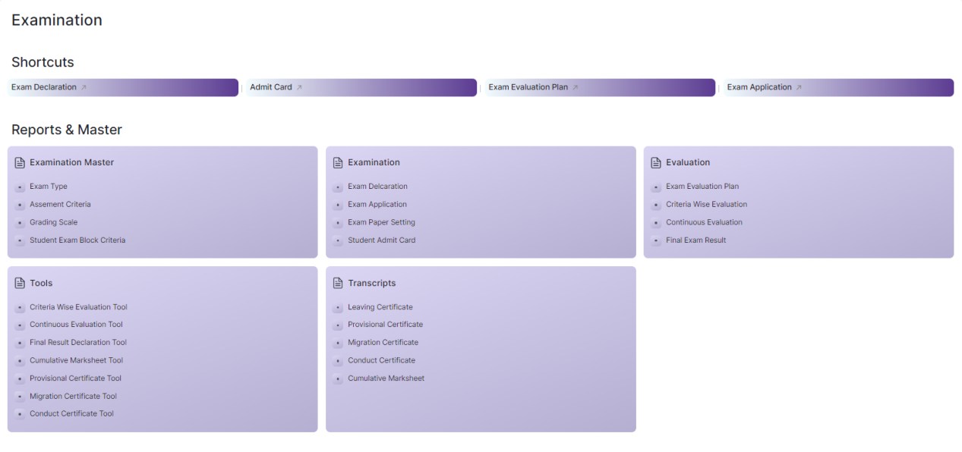

Figure 1 : Examination Home Screen

## Exam Type

**General Description**

|  |  |
| --- | --- |
| **Description** | The Exam Type allows user to create and set values for a particular Exam Declaration which shall be beneficial to determine the type of examinations that are being conducted and can be evaluated on the basis of it. For example, an Exam Declaration can be classified as Mid Term Examination or End Term Examination. |
| **Navigation** | Home > Examination > Examination Master > Exam Type |
| **Pre-requisites** |  |
| **Existing Screen Name** | Exam Type |
| **New Screen Name** | NA |

### **Screenshot**

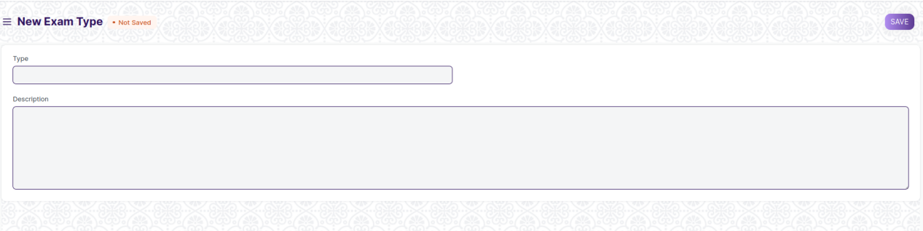

Figure 2 : Exam Type Screen

### **Field List**

The “Exam Type” screen shall consist of the following fields:

|  |  |  |  |  |  |  |
| --- | --- | --- | --- | --- | --- | --- |
| **ID** | **Field Label** | **Field Type** | **Validation/Action** | **Mandatory** | **Remarks** | **R/N/D** |
| 1 | Type | Text Field | User Input |  |  |  |
| 2 | Description | Long Text Field | User Input |  |  |  |

### **User: Roles & Permission**

The following table describes the users and their roles and permissions for the screens :

|  |  |  |  |  |  |  |  |  |
| --- | --- | --- | --- | --- | --- | --- | --- | --- |
| **ID** | **Role** | **Read** | **Write** | **Create** | **Delete** | **Submit** | **Cancel** | **Amend** |
| 1 | Admin | Yes | Yes | Yes | Yes | NA | NA | NA |
| 2 | Instructor | Yes | No | No | No | NA | NA | NA |
| 3 | Student | Yes | No | No | No | NA | NA | NA |

## **Assessment Criteria**

**General Description**

|  |  |
| --- | --- |
| **Description** | The Assessment Criteria various components of Continuous Evaluation on the basis of which evaluation shall be conducted. Also, multiple Assessment Criteria can be grouped together under Assessment Criteria Group as well as Maximum Credit can be allotted to them. It can also be linked with Exam Declaration if required. For example, Assessment Criteria can be specified as Mid Term, Practical, End Term, Quiz, Viva, etc. |
| **Navigation** | Home > Examination > Examination Master > Assessment Criteria |
| **Pre-requisites** |  |
| **Existing Screen Name** | Assessment Criteria |
| **New Screen Name** | Assessment Component |

**Screenshot**

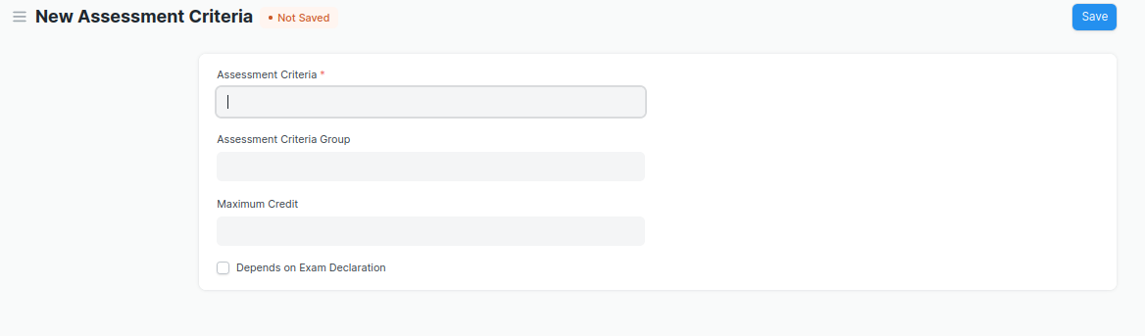

Figure 3 : Assessment Criteria Screen

**Field List**

The “Assessment Criteria” screen shall consist of the following fields:

|  |  |  |  |  |  |  |
| --- | --- | --- | --- | --- | --- | --- |
| **ID** | **Field Label** | **Field Type** | **Validation/Action** | **Mandatory** | **Remarks** | **R/N/D** |
| 1 | Assessment Criteria | Text Field | User Input | Yes |  | (R)Assessment Component |
| 2 | Assessment Criteria Group | Link Field | Fetched from Assessment Criteria Group master screen |  |  |  |
| 3 | Maximum Credit | Float | User Input |  |  | (D) |
| 4 | Depends on Exam Declaration | Check Box | User Input |  |  | (D) |

**User: Roles & Permission**

The following table describes the users and their roles and permissions for the screens :

|  |  |  |  |  |  |  |  |  |
| --- | --- | --- | --- | --- | --- | --- | --- | --- |
| **ID** | **Role** | **Read** | **Write** | **Create** | **Delete** | **Submit** | **Cancel** | **Amend** |
| 1 | Admin | Yes | Yes | Yes | Yes | NA | NA | NA |
| 2 | Instructor | Yes | No | No | No | NA | NA | NA |
| 3 | Student | Yes | No | No | No | NA | NA | NA |

## Grading Scale

**General Description**

|  |  |
| --- | --- |
| **Description** | Under Grading Scale, user can define the threshold for the different grades obtained by the students, based on their scores in the assessment. For example, students obtaining a score of 90% and above would be graded as A+, students obtaining a score of 80% and above would be graded A- and so on. |
| **Navigation** | Home > Examination > Examination Master > Grading Scale |
| **Pre-requisites** |  |
| **Existing Screen Name** | Grading Scale |
| **New Screen Name** | NA |

**Screenshot**

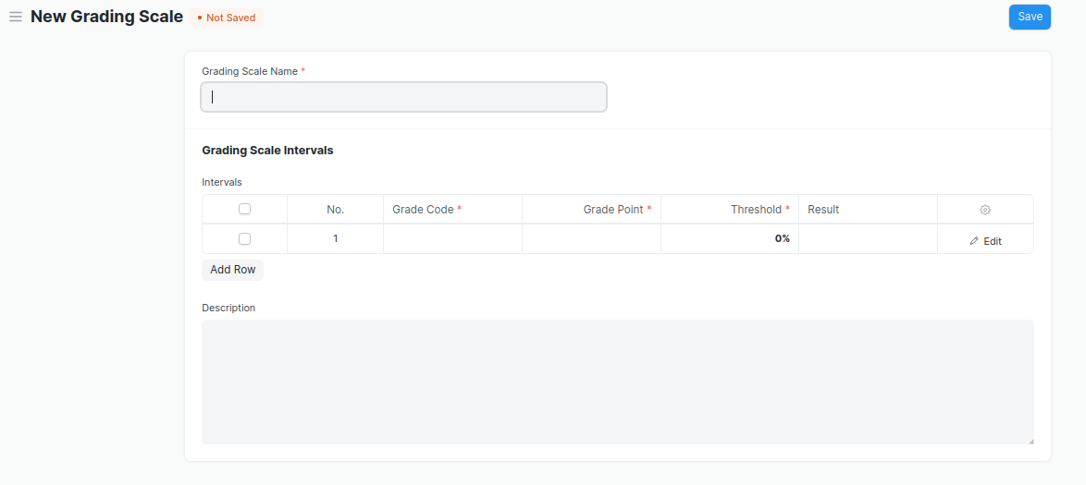

Figure 4 : Grading Scale Screen

**Field List**

The “Grading Scale” screen shall consist of the following fields:

|  |  |  |  |  |  |  |
| --- | --- | --- | --- | --- | --- | --- |
| **ID** | **Field Label** | **Field Type** | **Validation/Action** | **Mandatory** | **Remarks** | **R/N/D** |
| 1 | Grading Scale Name | Text Field | User Input | Yes |  |  |
| 2 | **Grading Scale Interval** | Table | User Input |  | These table is describe below |  |
| 3 | Description | Long Text Field | User Input |  |  |  |

|  |  |  |  |  |  |  |
| --- | --- | --- | --- | --- | --- | --- |
| **Grading Scale Interval** | | | | | | |
| **ID** | **Field Label** | **Field Type** | **Validation/Action** | **Mandatory** | **Remarks** | **R/N/D** |
| 1 | Grade Code | Text Field | User Input | Yes |  |  |
| 2 | Grade Point | Text Field | User Input | Yes |  |  |
| 3 | Threshold | Float | User Input | Yes |  |  |
| 4 | Result | Drop Down | PASS  FAIL |  |  |  |
| 5 | Grade Description | Long Text Field | User Input |  |  |  |

Note:

* WSC doesn’t need CGPA, they use module-wise grade, you must enter percentage in Grade Point field in Grading Scale table.

**User: Roles & Permission**

The following table describes the users and their roles and permissions for the screens :

|  |  |  |  |  |  |  |  |  |
| --- | --- | --- | --- | --- | --- | --- | --- | --- |
| **ID** | **Role** | **Read** | **Write** | **Create** | **Delete** | **Submit** | **Cancel** | **Amend** |
| 1 | Admin | Yes | Yes | Yes | Yes | Yes | Yes | Yes |
| 2 | Instructor | Yes | No | No | No | No | No | No |
| 3 | Student | Yes | No | No | No | No | No | No |

## Student Exam Block Criteria

**General Description**

|  |  |
| --- | --- |
| **Description** | The Student Exam Block Criteria is used to create various criteria based on which students are blocked from applying for an exam declaration. For example, Attendance and Fees can be used as Student Exam Block Criteria for an Exam Declaration. |
| **Navigation** | Home > Examination > Examination Master > Student Exam Block Criteria |
| **Pre-requisites** |  |
| **Existing Screen Name** | Student Exam Block Criteria |
| **New Screen Name** | NA |

**Screenshot**

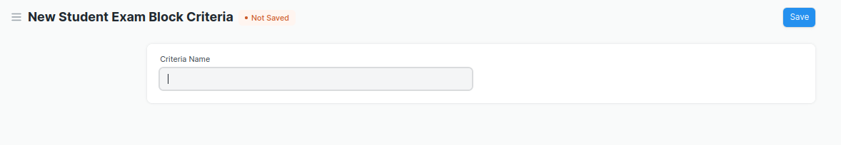

Figure 5 : Student Exam Block Criteria

**Field List**

The “Student Exam Block Criteria” screen shall consist of the following fields:

|  |  |  |  |  |  |  |
| --- | --- | --- | --- | --- | --- | --- |
| **ID** | **Field Label** | **Field Type** | **Validation/Action** | **Mandatory** | **Remarks** | **R/N/D** |
| 1 | Criteria Name | Text Field | User Input |  |  |  |

### **User: Roles & Permission**

The following table describes the users and their roles and permissions for the screens:

|  |  |  |  |  |  |  |  |  |
| --- | --- | --- | --- | --- | --- | --- | --- | --- |
| **ID** | **Role** | **Read** | **Write** | **Create** | **Delete** | **Submit** | **Cancel** | **Amend** |
| 1 | Admin | Yes | Yes | Yes | Yes | NA | NA | NA |
| 2 | Instructor | Yes | No | No | No | NA | NA | NA |
| 3 | Student | Yes | No | No | No | NA | NA | NA |

## Examination Transaction Screen

## Exam Declaration

**General Description**

|  |  |
| --- | --- |
| **Description** | The Exam Declaration will allow user to declare an exam for various programs in accordance with the ‘Academic Calendar’ template which was used during the start of each session. |
| **Navigation** | Home > Examination > Examination>Exam Declaration |
| **Pre-requisites** | 1. Academic Calendar 2. Program 3. Academic Year |
| **Existing Screen Name** | Exam Declaration |
| **New Screen Name** | Exam Schedule |

### **Screenshot**

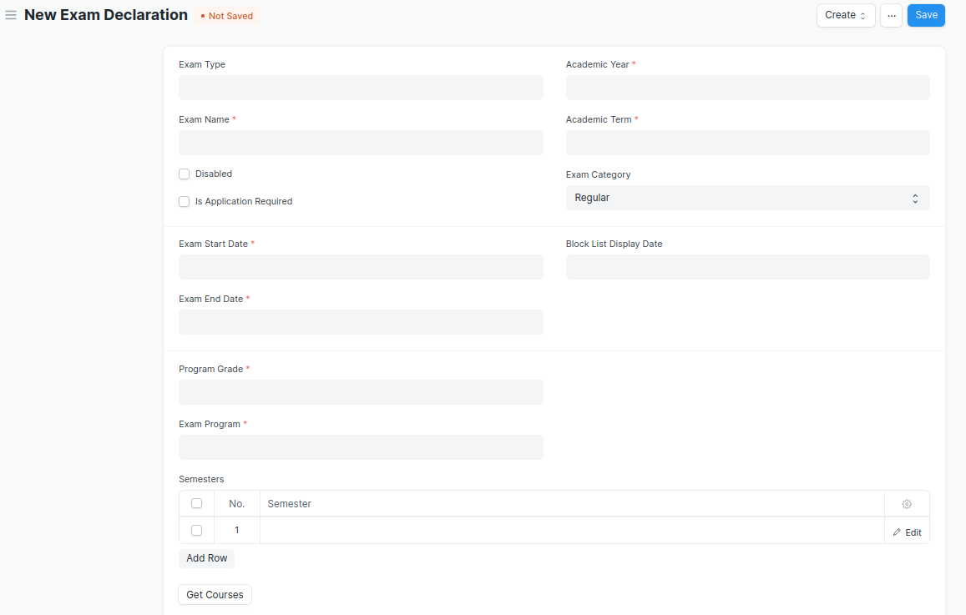

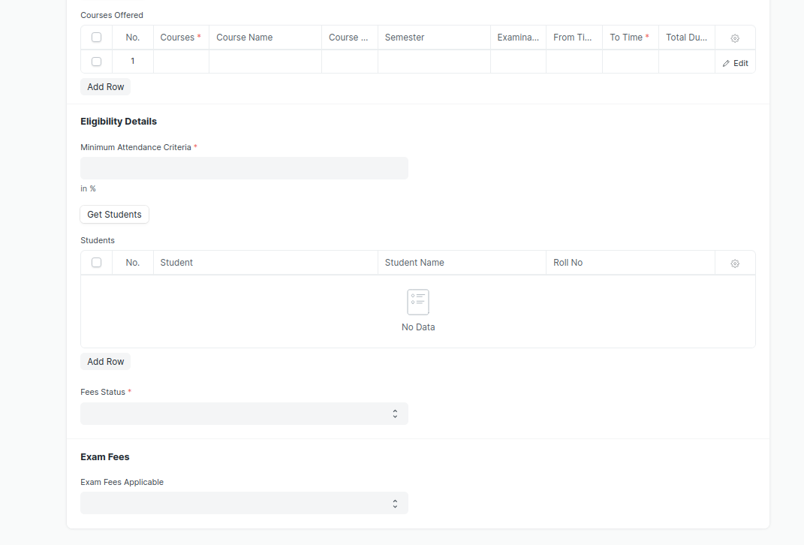

Figure 6 : Exam Declaration

### **Field List**

The “Exam Declaration” screen shall consist of the following fields:

|  |  |  |  |  |  |  |
| --- | --- | --- | --- | --- | --- | --- |
| **ID** | **Field Label** | **Field Type** | **Validation/Action** | **Mandatory** | **Remarks** | **R/N/D** |
|  | Program Grade | Link Field | Link Field to Program Grades master screen | Yes |  | 1. Course Grade |
|  | Exam Program | Link Field | Program will be fetched based from selected “Program Grade” | Yes | Link Field to Program Screen | (R) Course Name |
|  | **Semesters** | Table | Only those semesters list will come which belongs to the entered Exam Program | Yes | Description of this table is given below |  |
|  | Class | Link Field | Linked Field to Class Master Screen |  | Options:  Class A, Class B, Class C, Class D |  |
|  | Exam Type | Link Field | Link to Exam Type master screen | Yes | Eg. In-Module, End Module |  |
|  | Assessment Component | Link Field | 1. Link to Assessment Criteria Screen 2. Data will fetch based upon the exam type | Yes | Eg. Phase Test 1  Phase Test 2  Practical Assignment 1,  Practical Assignment 2, etc. |  |
|  | Exam Name | Text Field | User Input | Yes |  |  |
|  | Disabled | Checkbox | User Input |  |  |  |
|  | Is Application Required | Checkbox | User Input |  |  | (D) |
|  | Academic Year | Link Field | Fetched from Academic Year master screen | Yes |  |  |
|  | Academic Term | Link Field | Fetched from Academic Term master screen | Yes |  |  |
|  | Exam Category | Drop down | Regular/Re-Test |  |  |  |
|  | Application Form Start Date | Date Picker | Display and Mandatory if “Is Application Required” is checked |  |  | (D) |
|  | Application Form End Date | Date Picker | 1. Display and Mandatory if “Is Application Required” is checked 2. Should be greater than Start Date |  |  | (D) |
|  | Exam Start Date | Date Picker | User Input | Yes |  |  |
|  | Exam End Date | Date Picker | Should be greater than Start Date | Yes |  |  |
|  | Admit Card Issue Date | Date Picker | User Input |  |  |  |
|  | Block List Display Date | Date Picker | Date should be before “Exam Start Date” |  |  |  |
|  | Get Courses | Button | Courses will be fetched based on Selected “Exam Program” and “Semester” |  |  | (R) Get Modules |
|  | **Courses Offered** | Table | Only those courses will come which belongs to the entered semester | Yes | Description of this table is given below | (R) Modules Offered |
|  | Minimum Attendance Criteria | Float | User Input | Yes |  |  |
|  | Get Students | Button |  |  |  |  |
|  | Total Enrolled Student | Number | Calculated total number of Students fetched based on “Get Students” Button |  |  |  |
|  | **Students** | Table | Students will be fetched based on selected Course, Semester, Class, Academic Year, Academic Term |  | Description of this table is given below |  |
|  | Fees Status | Drop down | Full Paid/  More than 50%/  Allow all | Yes |  |  |
|  | Exam Fees Applicable | Drop down | By default It will be NO, if Fees Status is **Allow All** |  | YES/NO |  |
|  | **Fee Structure** | Table | If “Exam Fees Applicable” is “Yes” then the table will show |  | This table is described below |  |

|  |  |  |  |  |  |  |
| --- | --- | --- | --- | --- | --- | --- |
| **Semesters** | | | | | | |
| ID | **Field Label** | **Field Type** | **Validation/Action** | **Mandatory** | **Remarks** | **R/N/D** |
| 1 | Semester | Link Field | Fetched from Semester master screen and filtered based on Selected “Exam Program” | Yes |  |  |

|  |  |  |  |  |  |  |
| --- | --- | --- | --- | --- | --- | --- |
|  | **Courses Offered** | | | | | |
| ID | **Field Label** | **Field Type** | **Validation/Action** | **Mandatory** | **Remarks** | **R/N/D** |
| 1 | Courses | Link Field | Auto fetch based on “Get Courses” Button | Yes |  | (R) Modules |
| 2 | Course Name | Text field | Auto fetch based on “Get Courses” Button |  |  | (R) Modules Name |
| 3 | Course Code | Text field | Auto fetch based on “Get Courses” Button |  |  | (R) Modules Code |
| 4 | Semester | Link Field | Auto fetch based on “Get Courses” Button |  |  |  |
| 5 | Examination Start Date | Date Picker | Individual Module Examination Start date need to be between the exam Start Date and End Date | Yes | User Input |  |
| 6 | Examination End Date | Date Picker | Individual Module Examination End date need to be between the exam Start Date and End Date | Yes | User Input |  |
| 7 | From Time | Time | User Input | Yes |  |  |
| 8 | To Time | Time | User Input | Yes |  |  |
| 9 | Total Duration (in Hours) | Time | Calculated based on “From Time” & “To Time” |  |  |  |
| 10 | Marker | Link Field | Link Field to Instructor Screen |  |  |  |
| 11 | Checker | Link Field | Link Field to Instructor Screen |  |  |  |

|  |  |  |  |  |  |  |
| --- | --- | --- | --- | --- | --- | --- |
| **Students** | | | | | | |
| **ID** | **Field Label** | **Field Type** | **Validation/Action** | **Mandatory** | **Remarks** | **R/N/D** |
| 1 | Student | Text Field | Auto fetch based on “Get student” Button |  |  |  |
| 2 | Student Name | Text Field | Auto fetch based on “Get student” Button |  |  |  |
| 3 | Roll No | Text Field | Auto fetch based on “Get student” Button |  |  |  |
| 4 | Registration Number | Text Field | Auto fetch based on “Get student” Button |  |  | (D) |

|  |  |  |  |  |  |  |
| --- | --- | --- | --- | --- | --- | --- |
| **Fee Structure** | | | | | | |
| **ID** | **Field Label** | **Field Type** | **Validation/Action** | **Mandatory** | **Remarks** | **R/N/D** |
| 1 | Student Category | Link Field | Fetched from Student Category master screen | Yes |  |  |
| 2 | Fee Structure | Link Field | Fetched from Fee Structure master screen |  |  |  |
| 3 | Amount | Currency Field | Auto fetch based on “Fee Structure” |  |  |  |
| 4 | Due Date | Date Picker |  | Yes |  |  |

## Module Wise Exam Group

**General Description**

|  |  |
| --- | --- |
| **Description** | With the help of Exam Process Screen, a user can grouped students to giving the exams on the basis of batch, room capacity, lab examination, etc. |
| **Navigation** |  |
| **Pre-requisites** | Exam Declaration |
| **Existing Screen Name** |  |
| **New Screen Name** | Module Wise Exam Group |

### **Screenshot**

Figure 7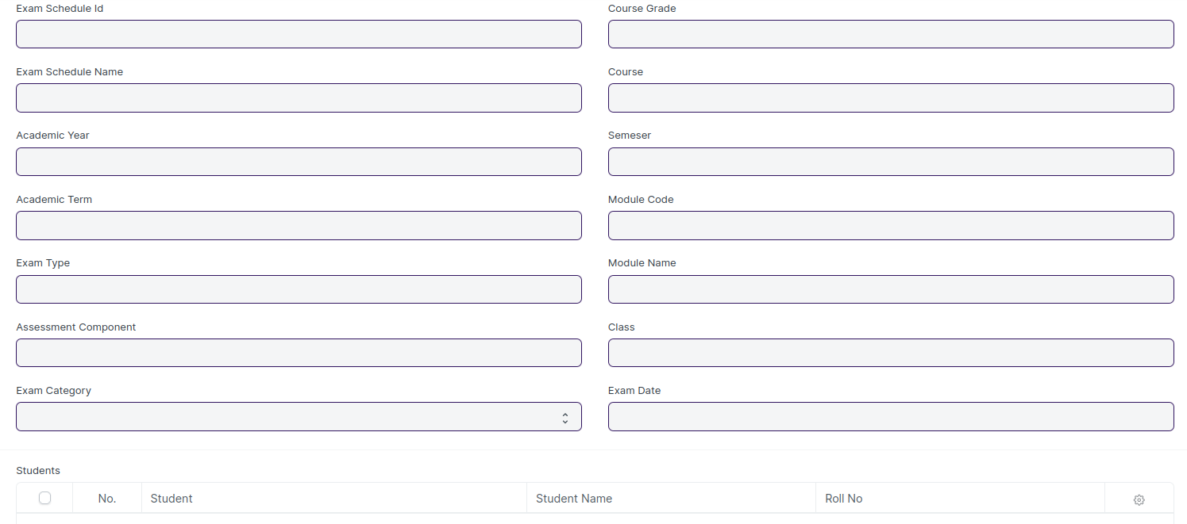 : Module Wise Exam Group

### **Field List**

The “Module Wise Exam Group” screen shall consist of the following fields:

|  |  |  |  |  |  |  |  |  |  |  |  |  |  |
| --- | --- | --- | --- | --- | --- | --- | --- | --- | --- | --- | --- | --- | --- |
| **ID** | | **Field Label** | **Field Type** | | **Validation/Action** | | **Mandatory** | | **Remarks** | | | **R/N/D** | |
|  | | Exam Schedule Id | Link Field | | Link Field to Exam Declaration Screen | | Yes | |  | | |  | |
|  | | Exam Schedule Name | Text Field | | Auto Fetched from Exam Declaration Screen | |  | |  | | |  | |
|  | | Academic Year | Link Field | | Link Field to Academic Year master screen | |  | |  | | |  | |
|  | | Academic Term | Link Field | | Link Field to Academic Term master screen | |  | |  | | |  | |
|  | | Exam Type | Link Field | | Link Field to Exam Type master screen | |  | | Eg. In Module, End Module | | |  | |
|  | | Assessment Component | Link Field | | 1. Link Field to Assessment Criteria Screen 2. Data will fetch based upon the exam type of Exam Declaration | |  | | Eg. Phase Test 1  Phase Test 2  Practical Assignment 1,  Practical Assignment 2, etc. | | |  | |
|  | | Total Marks | Number | | Auto Fetched from Course Screen | |  | |  | | |  | |
|  | | Exam Category | Dropdown | | Auto fetched from Exam declaration Screen | |  | | Options:  Regular  Re-Test | | |  | |
|  | | Course Grade | Link Field | | Auto fetched from Exam declaration Screen | |  | |  | | | (R)Course Grade | |
|  | | Course | Link Field | | Auto fetched from Exam declaration Screen | |  | | Link Field to Program Screen | | | (R) Course Name | |
|  | | **Semesters** | Table | | Auto fetched from Exam declaration Screen | |  | | Description of this table is given below | | |  | |
|  | | Module | Link | | Only those modules will come which are present in exam declaration course table | | Yes | |  | | |  | |
|  | | Module Name | Text Field | | Auto fetch when the user enters the module id. | |  | |  | | |  | |
|  | | Module Code | Text Field | | Auto fetch when the user enters the module code. | |  | |  | | |  | |
|  | | Class | Link Field | | Auto fetched from Exam declaration Screen | |  | | Options:  Class A, Class B, Class C, Class D | | |  | |
|  | | Exam Date | Date | | Date need to be entered on the basis Exam declaration between the start date and end date of Individual Modules. | | Yes | |  | | |  | |
|  | | Time | Time | | Auto fetch from exam declaration course table (Start Time) | |  | |  | | |  | |
|  | | Duration | Float | | Auto fetch from exam declaration course table | |  | |  | | |  | |
|  | | Marker’s Name | Link Field | | Link Field to Instructor Screen | | Yes | |  | | |  | |
|  | | Course Manager | Link Field | | Link Field to Instructor Screen | |  | |  | | |  | |
|  | | Get Student | Button | | On click students data will fetch in Student list Table on the basis of Course, Semester, Module, Class, Academic Year and Academic Term. | |  | |  | | |  | |
|  | | Student List | Table | | Description of this table is given below | |  | |  | | |  | |
| **Invigilaor’s List** | | | | | | | | | | | | | |
| **ID** | | **Field Label** | | | **Field Type** | | **Validation/Action** | | **Mandatory** | | **Remarks** | **R/N/D** | |
| 1 | | Invigilator Id | | | Link Field | | Link to Instructor Screen | |  | | Need to validate Duplicate Invigilators Name |  | |
| 2 | | Invigilator Name | | | Text Field | | Auto fetch based on Invigilator Id | |  | |  |  | |
| 3 | | Department | | | Link Field | | Auto fetch based on Invigilator Id | |  | |  |  | |

|  |  |  |  |  |  |  |
| --- | --- | --- | --- | --- | --- | --- |
| **Students** | | | | | | |
| **ID** | **Field Label** | **Field Type** | **Validation/Action** | **Mandatory** | **Remarks** | **R/N/D** |
| 1 | Student | Text Field | Auto fetch based on “Get student” Button |  | Need to validate Duplicate Students Name |  |
| 2 | Student Name | Text Field | Auto fetch based on “Get student” Button |  |  |  |
| 3 | Roll No | Text Field | Auto fetch based on “Get student” Button |  |  |  |
| 4 | Class Room | Link Field | 1. Link Field to Class Room Screen 2. Need to add validation regarding occupied and vacant class rooms. | Yes |  |  |
| 5 | Student Group | Dropdown | Options-   1. A 2. B 3. C 4. D | Yes |  |  |

### Exam Attendance Sheet Print Format

**General Description**

|  |  |
| --- | --- |
| **Description** | On Click of Print button in Examination Process Screen, a print format will be generated, it can also be converted into PDF format. |
| **Navigation** |  |
| **Pre-requisites** | Examination Process |
| **Existing Screen Name** |  |
| **New Screen Name** |  |

### **Exam Attendance Sheet Print Format Screenshot**

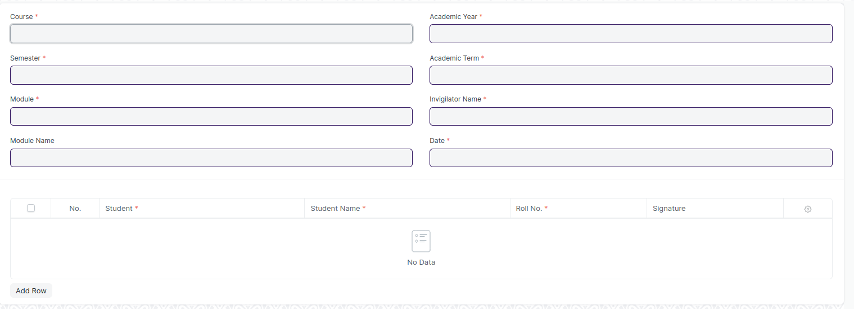

Figure 8 : Exam Attendance Sheet Print Format

### **Exam Attendance Sheet Print Format Field List**

The “Exam Attendance Sheet Print Format” screen shall consist of the following fields:

|  |  |  |  |
| --- | --- | --- | --- |
| **ID** | **Field Label** | **Field Type** | **Remarks** |
|  | Department | Text Field | Auto fetch data from Examination Process Screen |
|  | Course | Text Field | Auto fetch data from Examination Process Screen |
|  | Semester | Text Field | Auto fetch data from Examination Process Screen |
|  | Module Name | Text Field | Auto fetch data from Examination Process Screen |
|  | Class Name | Text Field | Auto fetch data from Examination Process Screen |
|  | Academic Year | Text Field | Auto fetch data from Examination Process Screen |
|  | Academic Term | Text Field | Auto fetch data from Examination Process Screen |
|  | Total Number of Students Present | Text Field | User Input |
|  | Total Number of Students Absent | Text Field | User Input |
|  | **Students** | **Table** | Auto fetch data from student table of Examination Process Screen |

|  |  |  |  |
| --- | --- | --- | --- |
| **Student List** | | | |
| **ID** | **Field Label** | **Field Type** | **Validation/Action** |
| 2 | Student Name | Text Field | Auto fetch based on “Exam Declaration” |
| 3 | Roll No | Text Field | Auto fetch based on “Exam Declaration” |
| 4 | Signature | Text Field |  |
| **Invigilators List** | | | |
| **ID** | **Field Label** | **Field Type** | **Validation/Action** |
| 2 | Invigilator Name | Text Field | Auto fetch based on Invigilator Id |
| 3 | Signature | Text Field |  |

### Exam Score Sheet Print Format

**General Description**

|  |  |
| --- | --- |
| **Description** | On Click of Print button in Exam Declaration Screen, a print format will be generated, it can also be converted into PDF format. |
| **Navigation** |  |
| **Pre-requisites** | Exam Declaration |
| **Existing Screen Name** |  |
| **New Screen Name** |  |

### **Exam Score Sheet Print Format Screenshot**

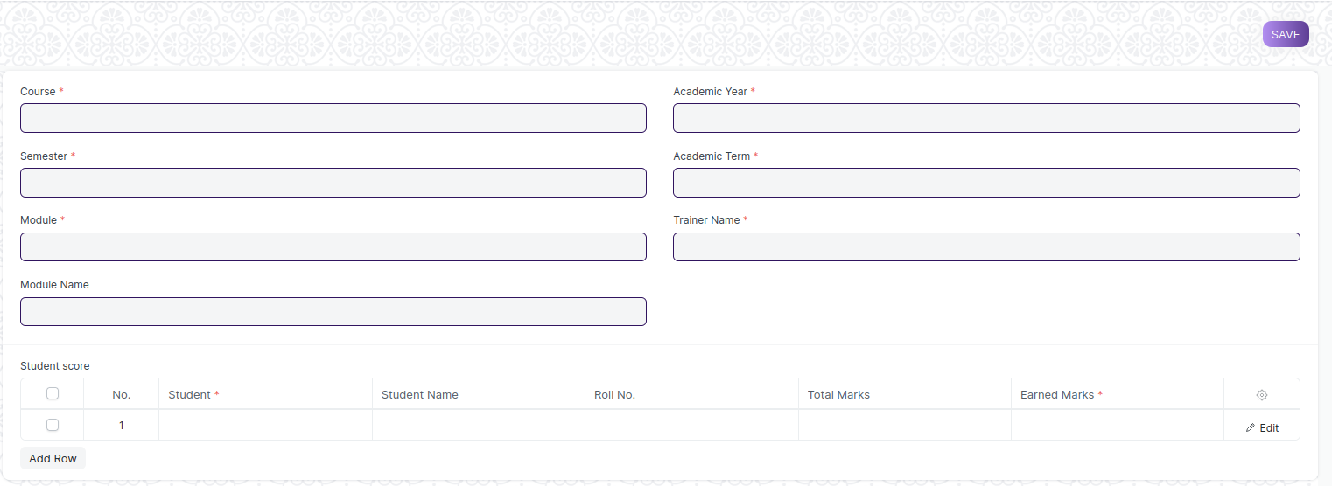

Figure 9 : Exam Score Sheet Print Format

### **Exam Score Sheet Print Format Field List**

The “Exam Score Sheet Print Format” screen shall consist of the following fields:

|  |  |  |  |
| --- | --- | --- | --- |
| **ID** | **Field Label** | **Field Type** | **Validation/Action** |
|  | Department | Text Field | Auto fetch based on “Examination process screen” |
|  | Course | Text Field | Auto fetch based on “Examination process screen” |
|  | Module Name | Text Field | Auto fetch based on “Examination process screen” |
|  | Academic Year | Text Field | Auto fetch based on “Examination process screen” |
|  | Academic Term | Text Field | Auto fetch based on “Examination process screen” |
|  | Date of Assignment | Text Field | Auto fetch based on “Examination process screen” |
|  | Assessmemt Component | Text Field | Auto fetch based on “Examination process screen” |
|  | Maximum Marks | Text Field | Auto fetch based on “Examination process screen” |
|  | Name & Signature of the Marker | Text Field | User Input |
|  | Name & Signature of the Course Manager | Text Field | User Input |
|  | **Students** | Table | Auto fetch based on “Examination process screen” |

|  |  |  |  |
| --- | --- | --- | --- |
| **Student List** | | | |
| **ID** | **Field Label** | **Field Type** | **Validation/Action** |
| 1 | Student | Text Field | Auto fetch based on “Exam Declaration” |
| 2 | Student Name | Text Field | Auto fetch based on “Exam Declaration” |
| 3 | Roll No | Text Field | Auto fetch based on “Exam Declaration” |
| 5 | Earned Marks | Number | User Input |

Note:

* A notification or mail will be sent directly to the student after the exam declaration are announced
* A field is required for exam Declaration to show which room.
* One field must be added to the course offered table of the Exam Declaration screen to identify the conducting venue for their respective courses
* A provision to assign an invigilator, a marker, and a checker should be included in the exam declaration screen for a specific course
* If a student fails either semester 1, they will have to take a retest before the start of semester 2
* Need to make a reminder for students and instructors regarding exams and send it before a certain time period. It should be applicable for both In-Module/End-Module. Also, reminder notifications could be sent to students /instructors prior to exam
* One of the user roles will be exam co-coordinator
* For attendance sheet, format must be the same across multiple modules but will have the names of respective modules, dates , student names and course name
* Also must have a provision for downloading the template and student will sign in the attendance sheet
* Once the semester starts, exam schedule is provided to the students within 15/30 days
* In-module academic calendar is issued 1 month prior to semester

### **User: Roles & Permission**

The following table describes the users and their roles and permissions for the screens :

|  |  |  |  |  |  |  |  |  |
| --- | --- | --- | --- | --- | --- | --- | --- | --- |
| **ID** | **Role** | **Read** | **Write** | **Create** | **Delete** | **Submit** | **Cancel** | **Amend** |
| 1 | Admin | Yes | Yes | Yes | Yes | Yes | Yes | Yes |
| 2 | Instructor | Yes | No | No | No | No | No | No |
| 3 | Student | Yes | No | No | No | No | No | No |

## Exam Evaluation Plan

**General Description**

|  |  |
| --- | --- |
| **Description** | An Exam Evaluation Plan is a schedule to conduct the examination/assessment of a particular course for a group of students studying that course in an on-going academic term. |
| **Navigation** | Home > Examination > Evaluation > Exam Evaluation Plan |
| **Pre-requisites** | 1. Exam Declaration 2. Instructor & Instructor Log 3. Program 4. Semester 5. Course 6. Student Group |
| **Existing Screen Name** | Exam Evaluation Plan |
| **New Screen Name** | Exam Paper Evaluation Plan |

### **Screenshot**

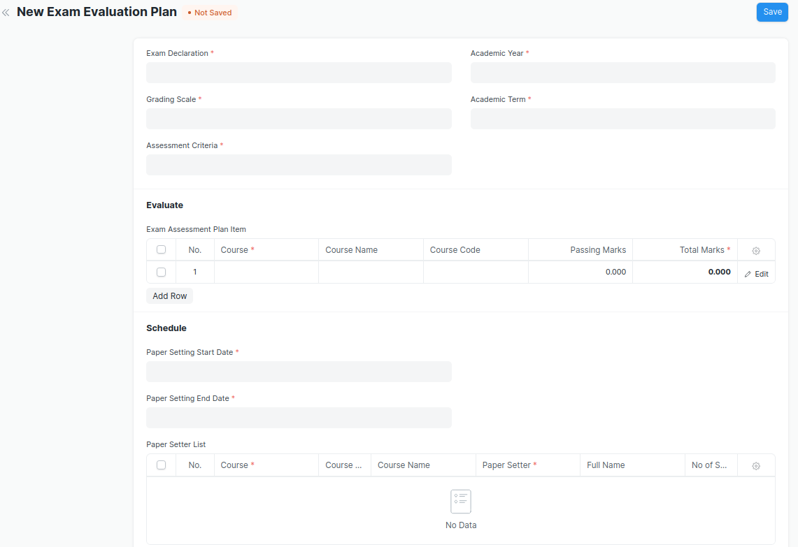

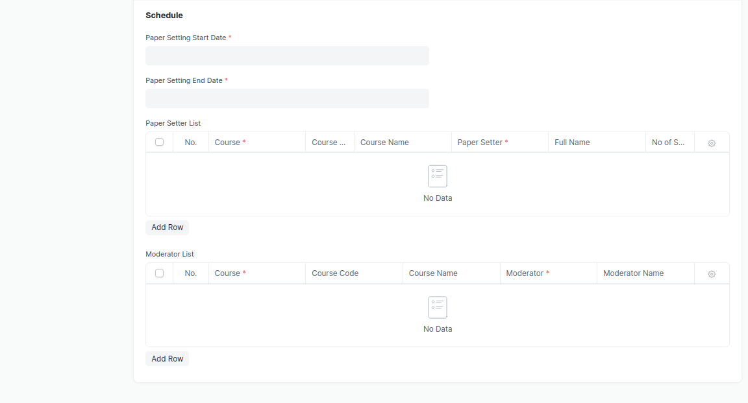

Figure 10 : Exam Evaluation Plan Screen

### **Field List**

The “Exam Evaluation Plan” screen shall consist of the following fields:

|  |  |  |  |  |  |  |
| --- | --- | --- | --- | --- | --- | --- |
| **ID** | **Field Label** | **Field Type** | **Validation/Action** | **Mandatory** | **Remarks** | **R/N/D** |
| 1 | Exam Declaration | Link Field | Fetched from Exam Declaration master screen | Yes |  | (R)Exam Schedule |
| 2 | Grading Scale | Link Field | Fetched from Grading Scale master screen | Yes |  |  |
| 3 | Assessment Criteria | Link Field | Fetched from Assessment Criteria master screen | Yes |  |  |
| 4 | Programs | Link Field | Auto fetch based on “Exam Declaration” | Yes |  | (R) Course |
| 5 | Semester | Link Field | Filtered will be applied based on selected “Programs” and existing “Exam Declaration” | Yes |  |  |
| 6 | Academic Year | Link Field | Auto fetch based on “Exam Declaration” | Yes |  |  |
| 7 | Academic Term | Link Field | Auto fetch based on “Exam Declaration” | Yes |  |  |
| 8 | **Exam Assessment Plan Item** | Table | Child Table: Course Assessment Plan Item | Yes | This table is described below |  |
| 9 | Paper Setting Start Date | Date Picker | User Input | Yes |  |  |
| 10 | Paper Setting End Date | Date Picker | User Input | Yes | On the basis of the end date, the paper setter needs to submit the paper sets, that he/she prepared |  |
| 11 | **Paper Setter List** | Table | Child Table: Moderator List |  | This tables is described below |  |
| 12 | **Moderator List** | Table | Child Table: Exam Assessment Plan |  | This table is described below |  |

|  |  |  |  |  |  |  |
| --- | --- | --- | --- | --- | --- | --- |
| **Exam Assessment Plan Item** | | | | | | |
| **ID** | **Field Label** | **Field Type** | **Validation/Action** | **Mandatory** | **Remarks** | **R/N/D** |
| 1 | Course | Link Field | Auto fetch based on selected “Programs” & “Semester” & “Assessment Criteria” | Yes |  | (R) Module |
| 2 | Course Name | Text Field | Auto fetch based on Course |  |  | (R) Module Name |
| 3 | Course Code | Text Field | Auto fetch based on Course |  |  | (R) Module Code |
| 4 | Passing Marks | Number | Auto fetch based on Course |  |  |  |
| 5 | Total Marks | Number | Auto fetch based on Course | Yes |  |  |
| 6 | Total Credit | Number | Auto fetch based on Course | Yes |  |  |

|  |  |  |  |  |  |  |
| --- | --- | --- | --- | --- | --- | --- |
| **Paper Setter List** | | | | | | |
| **ID** | **Field Label** | **Field Type** | **Validation/Action** | **Mandatory** | **Remarks** | **R/N/D** |
| 1 | Course | Link Field | Only fetch those courses which belongs to the selected semester | Yes |  | (R) Module |
| 2 | Course Code | Text Field | Auto fetch based on Course |  |  | (R) Module Code |
| 3 | Course Name | Text Field | Auto fetch based on Course |  |  | (R) Module Name |
| 4 | Paper Setter | Link Field | Fetched from Instructor master screen | Yes |  |  |
| 5 | Full Name | Text Field | Auto fetch based on Paper Setter |  |  |  |
| 6 | No of Sets | Number |  | Yes |  |  |

|  |  |  |  |  |  |  |
| --- | --- | --- | --- | --- | --- | --- |
| **Moderator List** | | | | | | |
| **ID** | **Field Label** | **Field Type** | **Validation/Action** | **Mandatory** | **Remarks** | **R/N/D** |
| 1 | Course | Link Field | Fetched those course which are present in Paper setter list | Yes |  | (R) Module |
| 2 | Course Code | Text Field | Auto fetch based on Course |  |  | (R) Module Code |
| 3 | Course Name | Text Field | Auto fetch based on Course |  |  | (R) Module Name |
| 4 | Moderator | Link Field | Fetched from Instructor master screen | Yes |  |  |
| 5 | Moderator Name | Text Field | Auto fetch based on Moderator |  |  |  |

### **Note:**

**Need to add Workflow in the following ways:-**

1. Paper setter will be assigned for a particular module in exam evaluation plan.
2. Paper setter will attach the paper sets and submit the record.
3. Once record will be submitted, along with the Paper Setter it will only be visible to the exam coordinator.
4. Once Exam Coordinator will send the paper sets to Moderator, then along with the Paper Setter and Exam Coordinator, It will only be visible to the Moderator.
5. Once Moderator Approved the paper set, Exam Coordinator will send the final paper set to examination cell.

### **User: Roles & Permission**

The following table describes the users and their roles and permissions for the screens :

|  |  |  |  |  |  |  |  |  |
| --- | --- | --- | --- | --- | --- | --- | --- | --- |
| **ID** | **Role** | **Read** | **Write** | **Create** | **Delete** | **Submit** | **Cancel** | **Amend** |
| 1 | Admin | Yes | Yes | Yes | Yes | Yes | Yes | Yes |
| 2 | Instructor | Yes | Yes | Yes | No | Yes | No | No |
| 3 | Student | Yes | No | No | No | No | No | No |

## Exam Paper Setting

**General Description**

|  |  |
| --- | --- |
| **Description** | The Exam Paper Setting is used to prepare paper setting schedules and plan for paper setters and moderators for a particular exam declaration. |
| **Navigation** | Home > Examination > Examination> Exam Paper |
| **Pre-requisites** | Exam Evaluation Plan |
| **Existing Screen Name** | Exam Paper Settings |
| **New Screen Name** | NA |

### **Screenshot**

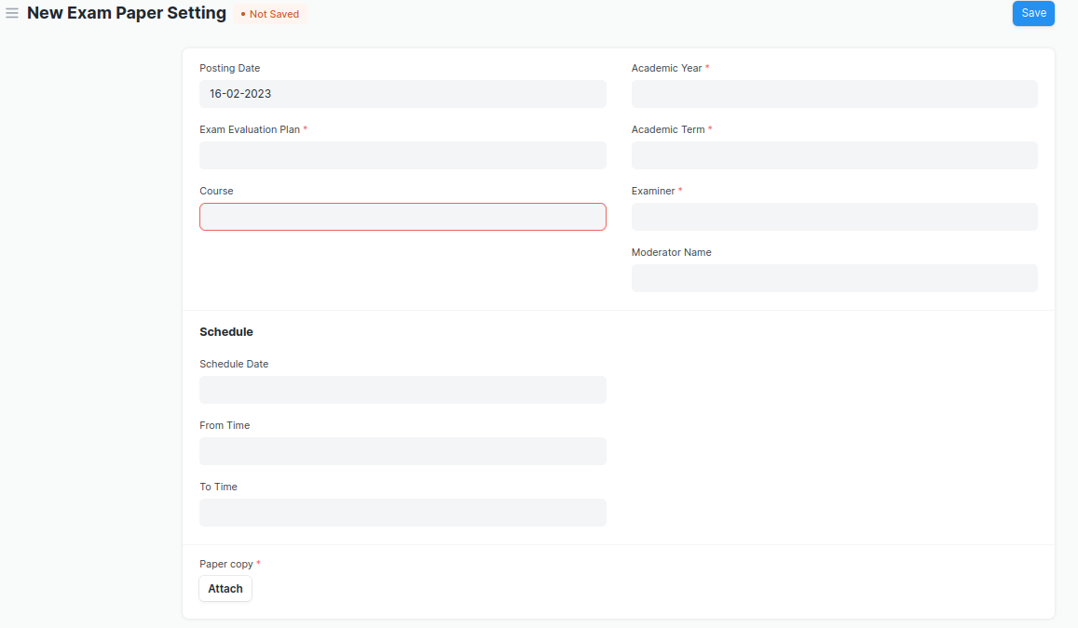

Figure 11 : Exam Paper Setting Screen

### **Field List**

The “Exam Paper Setting” screen shall consist of the following fields:

|  |  |  |  |  |  |  |
| --- | --- | --- | --- | --- | --- | --- |
| **ID** | **Field Label** | **Field Type** | **Validation/Action** | **Mandatory** | **Remarks** | **R/N/D** |
| 1 | Posting Date | Date | By default, Today’s date is fetched |  |  |  |
| 2 | Exam Evaluation Plan | Link Field | Fetched from Exam Evaluation Plan master screen | Yes |  |  |
| 3 | Programs | Link Field | Auto fetched based on “Exam Evaluation Plan” |  |  | (R) Course |
| 4 | Semester | Link Field | Auto fetched based on “Exam Evaluation Plan” |  |  |  |
| 5 | Course | Link Field | Course will be fetched based on selected “Exam Evaluation Plan” | Yes |  | (R) Module |
| 6 | Course Code | Text Field | Auto fetch based on Course |  |  | (R) Module Code |
| 7 | Course Name | Text Field | Auto fetch based on Course |  |  | (R) Module Name |
| 8 | Academic Year | Link Field | Auto fetched based on “Exam Evaluation Plan” | Yes |  |  |
| 9 | Academic Term | Link Field | Auto fetched based on “Exam Evaluation Plan” | Yes |  |  |
| 10 | Examiner | Link Field | Examiner will be fetched based on selected “Exam Evaluation Plan” |  |  |  |
| 11 | Examiner Name | Text Field | Examiner will be fetched based on selected “Exam Evaluation Plan” |  |  |  |
| 12 | Moderator Name | Link Field | Examiner will be fetched based on selected “Exam Evaluation Plan” |  |  |  |
| 13 | Schedule Date | Date picker | User Input |  |  |  |
| 14 | From Time | Time picker | User Input |  |  |  |
| 15 | To Time | Time picker | User Input |  |  |  |
| 16 | Paper copy | Attachment Button | 1. Attach button will only be visible to that instructor whose name is provided on paper setter list. 2. On attachment, a dialogue box will popup where the user can attach the files, take the picture with the help camera or can link any URL. 3. If photos or images attached then the size will be maximum 200 kb. | Yes |  |  |

Note:

* After the paper setter moderator list is published, the paper setter will take three weeks to set the paper, and the moderator will take three days to check the paper sets
* Once the paper setter created the paper sets,
* Then reminder sent to the director and Examination Head for review through mail
* Paper sets needs to be approved either by director or Examination Head
* Mail will be triggered to the paper setter and director when approved by Examination Head.

### **User: Roles & Permission**

The following table describes the users and their roles and permissions for the screens :

|  |  |  |  |  |  |  |  |  |
| --- | --- | --- | --- | --- | --- | --- | --- | --- |
| **ID** | **Role** | **Read** | **Write** | **Create** | **Delete** | **Submit** | **Cancel** | **Amend** |
| 1 | Admin | Yes | Yes | Yes | Yes | Yes | Yes | Yes |
| 2 | Instructor | Yes | Yes | Yes | No | Yes | No | No |
| 3 | Student | Yes | No | No | No | No | No | No |

## Criteria Wise Evaluation

**General Description**

|  |  |
| --- | --- |
| **Description** | Criteria Wise Evaluation allows us to create an evaluation for a particular assessment criterion in a course for a student enrolled in that course. |
| **Navigation** | Home > Examination > Evaluation > Criteria Wise Evaluation |
| **Pre-requisites** | 1. Exam Declaration 2. Course 3. Assessment Criteria 4. Grading Scale |
| **Existing Screen Name** | Criteria Wise Evaluation |
| **New Screen Name** | NA |

### **Screenshot**

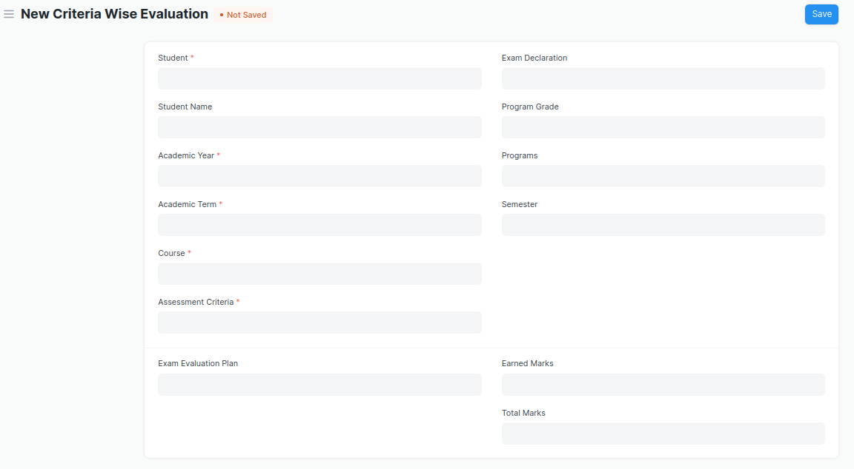

Figure 12 : Criteria Wise Evaluation Screen

* Two instructors independently evaluate a student's assessment without knowing the other's score and then come together to compare their results and determine the final grade.

### **Field List**

The “Criteria Wise Evaluation” screen shall consist of the following fields:

|  |  |  |  |  |  |  |
| --- | --- | --- | --- | --- | --- | --- |
| **ID** | **Field Label** | **Field Type** | **Validation/Action** | **Mandatory** | **Remarks** | **R/N/D** |
| 1 | Student | Link Field | Fetched from student master screen | Yes |  | (R) Student Id |
| 2 | Student Name | Text Field | Auto fetch based on Student |  |  |  |
| 3 | Roll No | Text Field | Auto fetch based on Student |  |  |  |
| 4 | Registration Number | Text Field | Auto fetch based on Student |  |  |  |
| 5 | Academic Year | Link Field | Auto fetched based on selected “Exam Declaration” | Yes |  |  |
| 6 | Academic Term | Link Field | Auto fetched based on selected “Exam Declaration” | Yes |  |  |
| 7 | Course | Link Field | Fetched from Course master screen, filtered will be applied Student enrolled course | Yes |  | (R) Module |
| 8 | Course Name | Text Field | Auto fetch based on Course |  |  | (R) Module Name |
| 9 | Assessment Criteria | Link Field | Fetched from Assessment Criteria master screen | Yes |  |  |
| 10 | Exam Declaration | Link Field | Fetched from Exam Declaration master screen |  |  |  |
| 11 | Program Grade | Link Field | Fetched from Program Grades master screen |  |  | (R) Course Grade |
| 12 | Programs | Link Field | Auto fetched based on selected “Exam Declaration” |  |  | (R) Course |
| 13 | Semester | Link Field | Fetched from Semester master screen,filtered will be applied to selected programs |  |  |  |
| 14 | Exam Assessment Plan | Link Field | Fetched from Exam Assessment Plan master screen |  |  |  |
| 15 | Earned Marks | Float |  |  |  |  |
| 16 | Total Marks | Float | Auto fetched based on selected Course from Course master |  |  |  |

### **User: Roles & Permission**

The following table describes the users and their roles and permissions for the screens :

|  |  |  |  |  |  |  |  |  |
| --- | --- | --- | --- | --- | --- | --- | --- | --- |
| **ID** | **Role** | **Read** | **Write** | **Create** | **Delete** | **Submit** | **Cancel** | **Amend** |
| 1 | Admin | Yes | Yes | Yes | Yes | Yes | Yes | Yes |
| 2 | Instructor | Yes | Yes | Yes | No | Yes | No | No |
| 3 | Student | Yes | No | No | No | No | No | No |

## Criteria Wise Evaluation Tool

**General Description**

|  |  |
| --- | --- |
| **Description** | Criteria Wise Evaluation Tool helps in entering marks earned by the students in a semester for a particular course and particular assessment criteria. |
| **Navigation** | Home > Examination > Tools > Criteria Wise Evaluation Tool |
| **Pre-requisites** | 1. Exam Declaration 2. Course 3. Assessment Criteria 4. Grading Scale |
| **Existing Screen Name** | Criteria Wise Evaluation Tool |
| **New Screen Name** | NA |

### **Screenshot**

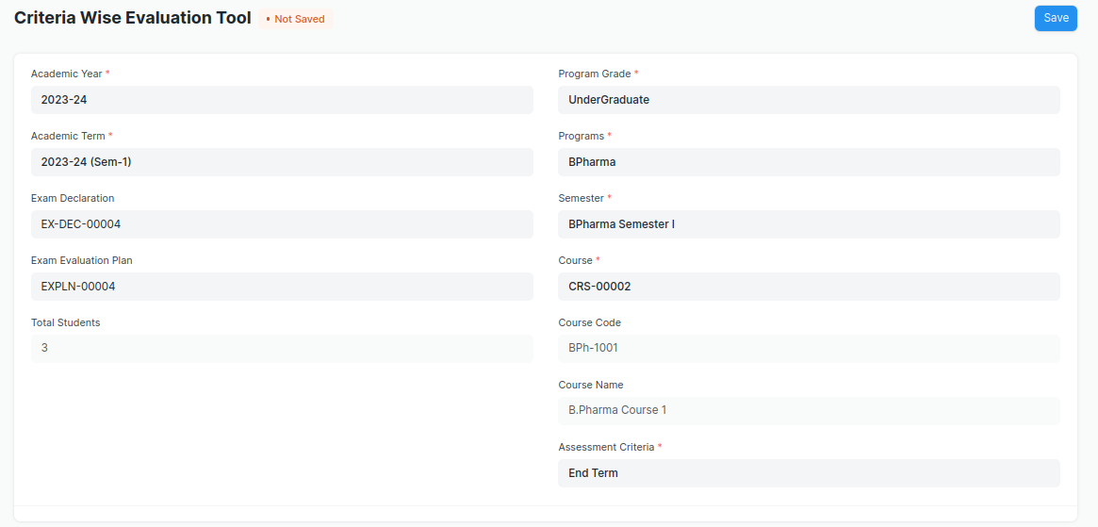

Figure 13 : Criteria Wise Evaluation Tool Screen

### **Field List**

The “Criteria Wise Evaluation Tool” screen shall consist of the following fields:

|  |  |  |  |  |  |  |
| --- | --- | --- | --- | --- | --- | --- |
| **ID** | **Field Label** | **Field Type** | **Validation/Action** | **Mandatory** | **Remarks** | **R/N/D** |
| 1 | Academic Year | Link Field | Fetched from Academic Year master screen | Yes |  |  |
| 2 | Academic Term | Link Field | Fetched from Academic Term master screen and filter applied on the basis of Academic Year | Yes |  |  |
| 3 | Exam Declaration | Link Field | Fetched from Exam Declaration master screen and filtered applied on the basis of Semester and Academic Term |  |  |  |
| 4 | Exam Assessment Plan | Link Field | Fetched from Exam Assessment Plan master screen |  |  |  |
| 5 | Total Students | Number |  |  |  |  |
| 6 | Program Grade | Link Field | Fetched from Program Grades master screen |  |  | (R)  Course Grade |
| 7 | Programs | Link Field | Fetched from Programs master screen, filtered applied on the basis of Program Grade |  |  | (R)  Courses |
| 8 | Semester | Link Field | Fetched from Program master screen and filtered applied on the basis of Programs |  |  |  |
| 9 | Course | Link Field | Fetched from Course master screen and filtered applied on the basis of Semester | Yes |  | (R)  Module |
| 10 | Course Code | Text Field | Auto fetch based on Course |  |  | (R)  Module Code |
| 11 | Course Name | Text Field | Auto fetch based on Course |  |  | (R)  Module Name |
| 12 | Assessment Criteria | Link Field | Fetched from Assessment Criteria master screen | Yes |  | (R)Assessment Component |
| 13 | **Student Details Data** | Table | HTML |  | This table is described below |  |

|  |  |  |  |  |  |  |
| --- | --- | --- | --- | --- | --- | --- |
| **Student Details Data** | | | | | | |
| **ID** | **Field Label** | **Field Type** | **Validation/Action** | **Mandatory** | **Remarks** | **R/N/D** |
| 1 | Student | HTML Field | Auto fetched when all the above relevant inputs given |  |  | (R) Student Id |
| 2 | Student Name | HTML Field | Auto fetched when all the above relevant inputs given |  |  |  |
| 3 | Roll No | HTML Field | Auto fetched when all the above relevant inputs given |  |  |  |
| 4 | Earned Marks | HTML Field | Auto fetched when all the above relevant inputs given |  |  |  |
| 5 | Total Marks | HTML Field | Auto fetched when all the above relevant inputs given |  |  |  |

### **User: Roles & Permission**

The following table describes the users and their roles and permissions for the screens :

|  |  |  |  |  |  |  |  |  |
| --- | --- | --- | --- | --- | --- | --- | --- | --- |
| **ID** | **Role** | **Read** | **Write** | **Create** | **Delete** | **Submit** | **Cancel** | **Amend** |
| 1 | Admin | Yes | Yes | Yes | Yes | Yes | Yes | Yes |
| 2 | Instructor | Yes | Yes | Yes | No | Yes | No | No |
| 3 | Student | Yes | No | No | No | No | No | No |

## Continuous Evaluation

**General Description**

|  |  |
| --- | --- |
| **Description** | Continuous Evaluation is used to assess the Assessment Criteria done for a course for an individual student. |
| **Navigation** | Home > Examination > Evaluation > Continuous Evaluation |
| **Pre-requisites** | Criteria Wise Evaluation |
| **Existing Screen Name** | Continuous Evaluation |
| **New Screen Name** | Rechecking Process |

### **Screenshot**

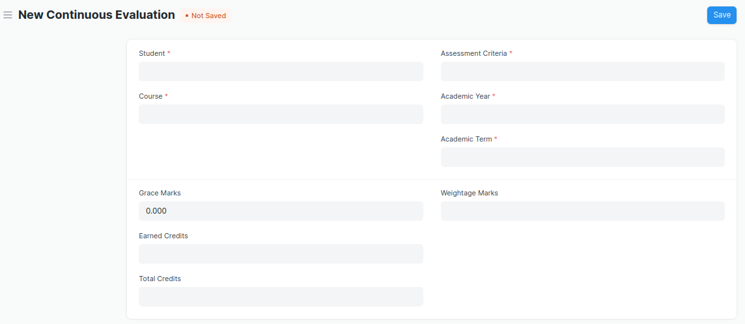

Figure 14 : Continuous Evaluation Screen

### **Field List**

The “Continuous Evaluation” screen shall consist of the following fields:

|  |  |  |  |  |  |  |
| --- | --- | --- | --- | --- | --- | --- |
| **ID** | **Field Label** | **Field Type** | **Validation/Action** | **Mandatory** | **Remarks** | **R/N/D** |
| 1 | Student | Link Field | Fetched from student master screen | Yes |  | (R) Student Id |
| 2 | Student Name | Text Field | Auto fetch based on Student |  |  |  |
| 3 | Course | Link Field | Fetched from Course master screen | Yes |  | (R) Module |
| 4 | Roll No | Text Field | Auto fetch based on Student |  |  |  |
| 5 | Registration Number | Text Field | Auto fetch based on Student |  |  | (D) |
| 6 | Course Code | Text Field | Auto fetch based on Course |  |  | (R) Module Code |
| 7 | Course Name | Text Field | Auto fetch based on Course |  |  | (R) Module Name |
| 8 | Assessment Criteria | Link Field | Fetched from Assessment Criteria master screen | Yes |  |  |
| 9 | Academic Year | Link Field | Fetched from Academic Year master screen | Yes |  |  |
| 10 | Academic Term | Link Field | Fetched from Academic Term master screen | Yes |  |  |
| 11 | Get Assessments | Button | User Input |  |  |  |
| 12 | **Final Credit Item** | Table | Child Table: Final Credit Item | Yes | This table is described below | (R)Final Module Marks |
| 13 | Grace Marks | Float | User Input If needed |  |  |  |
| 14 | Earned Credits | Float |  |  |  | ( D ) |
| 15 | Total Credits | Float |  |  |  | ( D ) |
| 16 | Weightage Marks | Float | Fetched from Course master screen |  |  |  |
| 17 | Final Marks | Float | Fetched from criteria wise evaluation screen respective record | Yes |  |  |
| 18 | Out of Marks | Float | Fetched from Course master screen |  |  |  |

|  |  |  |  |  |  |  |
| --- | --- | --- | --- | --- | --- | --- |
| **Final Credit Item** | | | | | | |
| **ID** | **Field Label** | **Field Type** | **Validation/Action** | **Mandatory** | **Remarks** | **R/N/D** |
| 1 | Course Assessment | Link Field | Fetched from Course Assessment master screen |  |  |  |
| 2 | Earned Marks | Float | Auto Fetched from criteria wise evaluation screen respective record |  |  |  |
| 3 | Grace Marks | Float | User Input If needed |  |  |  |
| 4 | Total Marks | Float | Auto Fetched from criteria wise evaluation screen respective record |  |  |  |

Note:

* The weight-age for In-module is 60% and End-module is 40%

### **User: Roles & Permission**

The following table describes the users and their roles and permissions for the screens :

|  |  |  |  |  |  |  |  |  |
| --- | --- | --- | --- | --- | --- | --- | --- | --- |
| **ID** | **Role** | **Read** | **Write** | **Create** | **Delete** | **Submit** | **Cancel** | **Amend** |
| 1 | Admin | Yes | Yes | Yes | Yes | Yes | Yes | Yes |
| 2 | Instructor | Yes | Yes | Yes | No | Yes | No | No |
| 3 | Student | Yes | No | No | No | No | No | No |

## Continuous **Evaluation Tool**

**General Description**

|  |  |
| --- | --- |
| **Description** | Continuous Evaluation Tool is used to assess the Assessment Criteria done for a course for an individual student. |
| **Navigation** | Home > Examination > Tools > Continuous Evaluation Tool |
| **Pre-requisites** | Criteria Wise Evaluation |
| **Existing Screen Name** | Continuous Evaluation Tool |
| **New Screen Name** | Rechecking Process Tool |

### **Screenshot**

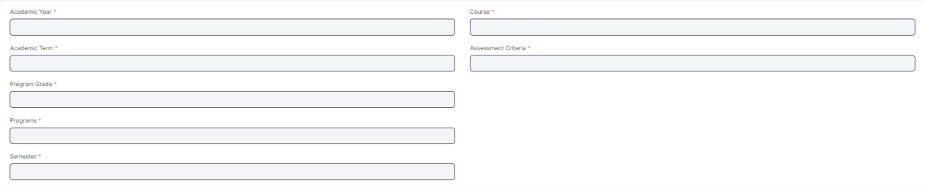

Figure 15 : Continuous Evaluation Screen

### **Field List**

The “Continuous Evaluation Tool” screen shall consist of the following fields:

|  |  |  |  |  |  |  |
| --- | --- | --- | --- | --- | --- | --- |
| **ID** | **Field Label** | **Field Type** | **Validation/Action** | **Mandatory** | **Remarks** | **R/N/D** |
| 1 | Academic Year | Link Field | Fetched from Academic Year master screen | Yes |  |  |
| 2 | Academic Term | Link Field | Fetched from Academic Term master screen and filtered applied on the basis of Academic Year | Yes |  |  |
| 3 | Program Grade | Link Field | Fetched from Program Grades master screen | Yes |  | (R) Course Grade |
| 4 | Programs | Link Field | Fetched from Programs master screen and filtered applied on the basis of Program Grades |  |  | (R) Courses |
| 5 | Semester | Link Field | Fetched from Program master screen and filtered applied on the basis of Programs |  |  |  |
| 6 | Course | Link Field | Fetched from Course master screen and filtered applied on the basis of Semester | Yes |  | (R) Module |
| 7 | Course Code | Text Field | Auto fetch based on Course |  |  | (R) Module Code |
| 8 | Course Name | Text Field | Auto fetch based on Course |  |  | (R) Module Name |
| 9 | Assessment Criteria | Link Field | Fetched from Assessment Criteria master screen | Yes |  | (R)Assessment Component |
| 10 | Student Inputs | HTML |  |  |  |  |

|  |  |  |  |  |  |  |
| --- | --- | --- | --- | --- | --- | --- |
| **Student Details Data** | | | | | | |
| **ID** | **Field Label** | **Field Type** | **Validation/Action** | **Mandatory** | **Remarks** | **R/N/D** |
| 1 | Student | HTML Field | Auto fetched when all the above relevant inputs given |  |  | (R)Student Id |
| 2 | Student Name | HTML Field | Auto fetched when all the above relevant inputs given |  |  |  |
| 3 | Roll No | HTML Field | Auto fetched when all the above relevant inputs given |  |  |  |
| 4 | Earned Marks | HTML Field | Auto fetched when all the above relevant inputs given |  |  |  |
| 5 | Total Marks | HTML Field | Auto fetched when all the above relevant inputs given |  |  |  |

Note:

1. Marker/ Trainer will only able to give marks in Criteria Wise Evaluation Screen.
2. Marker/ Trainer will not be able to change any thing after submission of Marks on Criteria Wise Evaluation Screen.
3. Exam Coordinator/Examination Cell Will Recheck - Add or subtract the marks in the Rechecking Process Screen which was given by the Trainer/Marker in the Criteria Wise Evaluation Screen.
4. Once Finalized the Marks and Records Submitted by the Exam Coordinator/ Examination Cell, Director Needs to Approved the Records.
5. Once Marks are approved by the Director, Examination Cell can publish the record on Final Exam Result Screen.

### **User: Roles & Permission**

The following table describes the users and their roles and permissions for the screens :

|  |  |  |  |  |  |  |  |  |
| --- | --- | --- | --- | --- | --- | --- | --- | --- |
| **ID** | **Role** | **Read** | **Write** | **Create** | **Delete** | **Submit** | **Cancel** | **Amend** |
| 1 | Admin | Yes | Yes | Yes | Yes | Yes | Yes | Yes |
| 2 | Instructor | Yes | No | No | No | No | No | No |
| 3 | Student | Yes | No | No | No | No | No | No |

## Final Exam Result

**General Description**

|  |  |
| --- | --- |
| **Description** | Final Exam Result is used to evaluate the final assessment of a student for a particular semester. |
| **Navigation** | Home > Examination > Evaluation > Final Exam Result |
| **Pre-requisites** | Continuous Evaluation |
| **Existing Screen Name** | Final Exam Result |
| **New Screen Name** | Final Semester Result |

### **Screenshot**

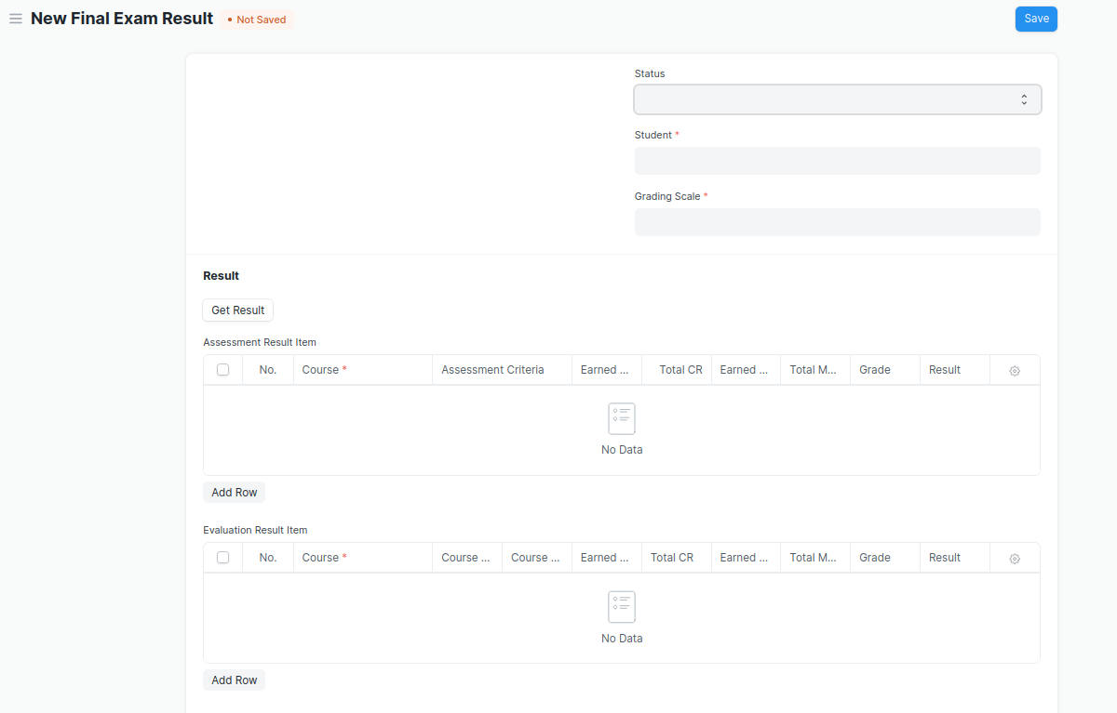

Figure 16 : Final Exam Result Screen

### **Field List**

The “Final Exam Result” screen shall consist of the following fields:

|  |  |  |  |  |  |  |
| --- | --- | --- | --- | --- | --- | --- |
| **ID** | **Field Label** | **Field Type** | **Validation/Action** | **Mandatory** | **Remarks** | **R/N/D** |
| 1 | Programs | Link Field | Auto fetch when Student Id is entered |  |  | (R) Courses |
| 2 | Semester | Link Field | Needs to be entered manually. |  |  |  |
| 3 | Course | Link Field | Auto fetch when Student Id is entered |  |  | (R) Module |
| 4 | Academic Year | Link Field | Auto fetch when Student Id is entered |  |  |  |
| 5 | Academic Term | Link Field | Needs to be entered manually |  |  |  |
| 6 | Student | Link Field | Fetched from student master screen |  |  | (R)Student Id |
| 7 | Student Name | Text Field | Auto fetch when Student Id is entered |  |  |  |
| 8 | Roll No | Text Field | Auto fetch when Student Id is entered |  |  |  |
| 9 | Registration Number | Text Field | Auto fetch when Student Id is entered |  |  | (D) |
| 10 | Grading Scale | Link Field | Fetched from Grading Scale master screen |  |  |  |
| 11 | Assessment Status | Text Field |  |  |  |  |
| 12 | Get Result | Button |  |  |  |  |
| 13 | **Assessment Result Item** | Table | After Clicking on Get Result, the **Assessment Result Item** table will auto fetch**.** |  | This table is described below |  |
| 14 | **Evaluation Result Item** | Table | This table will visible when a record is in **Draft** Status |  | This table is described below |  |
| 15 | Result | Text Field | Auto Calculated after saving the record |  | Pass/Fail |  |
| 16 | Total Marks | Number | Auto calculated from Evaluation Result Item Table Total Marks Field |  |  |  |
| 17 | Secured Marks | Number | Auto calculated from Evaluation Result Item Table Earned Marks Field |  |  |  |
| 18 | Comment | Small Text Field |  |  |  |  |
| 19 | SGPA |  |  |  |  | ( D ) |
| 20 | Overall CGPA |  |  |  |  | ( D ) |

|  |  |  |  |  |  |  |
| --- | --- | --- | --- | --- | --- | --- |
| **Assessment Result Item** | | | | | | |
| **ID** | **Field Label** | **Field Type** | **Validation/Action** | **Mandatory** | **Remarks** | **R/N/D** |
| 1 | Course | Link Field | Fetched from Course master screen | Yes |  | (R) Module |
| 2 | Assessment Criteria | Link Field | Fetched from Assessment Criteria master screen |  |  | (R)Assessment Component |
| 3 | Earned CR | Float | Auto fetched on the basis of Get Result Button |  |  | ( D ) |
| 4 | Total CR | Float | Auto fetched on the basis of Get Result Button |  |  | ( D ) |
| 5 | Earned Marks | Float | Auto fetched on the basis of Get Result Button |  |  |  |
| 6 | Total Marks | Float | Auto fetched on the basis of Get Result Button |  |  |  |
| 7 | Grade | Text Field | Auto fetched on the basis of Get Result Button |  |  |  |
| 8 | Result | Drop down | Auto fetched on the basis of Get Result Button | P/F |  |  |

|  |  |  |  |  |  |  |
| --- | --- | --- | --- | --- | --- | --- |
| **Evaluation Result Item (This table will visible when the record is in draft stage)** | | | | | | |
| **ID** | **Field Label** | **Field Type** | **Validation/Action** | **Mandatory** | **Remarks** | **R/N/D** |
| 1 | Course | Link Field | Fetched from Course master screen | Yes |  | (R) Module |
| 2 | Course Code | Text Field | Auto fetch based on Course |  |  | (R) Module Code |
| 3 | Course Name | Text Field | Auto fetch based on Course |  |  | (R) Module Name |
| 4 | Earned CR | Float |  |  |  | ( D ) |
| 5 | Total CR | Text Field |  |  |  | ( D ) |
| 6 | Earned Marks | Text Field |  |  |  |  |
| 7 | Total Marks | Text Field |  |  |  |  |
| 8 | Grade | Text Field |  |  |  |  |
| 9 | Result | Drop down | P/F |  |  |  |

Note:

* Remove/Hide the CGPA, SGPA, and Credit features from the Final Exam Result and display the percentage and grade instead
* Students must have access to view their results/reports
* A pictorial representation of student’s final results is required
* If a student is absent or fails during a semester exam, then student's data such as next program enrollment should not affect

### **User: Roles & Permission**

The following table describes the users and their roles and permissions for the screens :

|  |  |  |  |  |  |  |  |  |
| --- | --- | --- | --- | --- | --- | --- | --- | --- |
| **ID** | **Role** | **Read** | **Write** | **Create** | **Delete** | **Submit** | **Cancel** | **Amend** |
| 1 | Admin | Yes | Yes | Yes | Yes | Yes | Yes | Yes |
| 2 | Instructor | Yes | Yes | Yes | No | Yes | No | No |
| 3 | Student | Yes | No | No | No | No | No | No |

## Final Result Declaration Tool

**General Description**

|  |  |
| --- | --- |
| **Description** | Final Result Declaration Tool is used to declare the final exam results for a particular group/batch of students in a semester. |
| **Navigation** | Home > Examination > Tools > Final Result Declaration Tool |
| **Pre-requisites** | Continuous Evaluation |
| **Existing Screen Name** | Final Result Declaration Tool |
| **New Screen Name** | NA |

### **Screenshot**

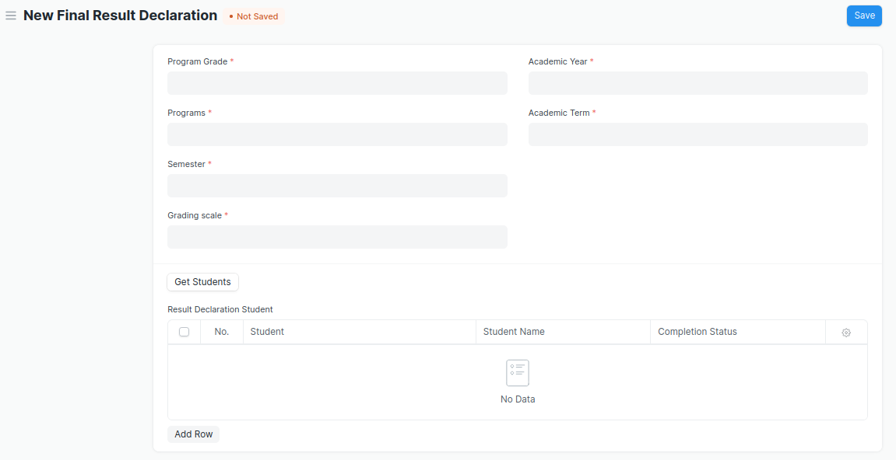

Figure 17 : Final Result Declaration Tool Screen

### **Field List**

The “Final Result Declaration Tool” screen shall consist of the following fields:

|  |  |  |  |  |  |  |
| --- | --- | --- | --- | --- | --- | --- |
| **ID** | **Field Label** | **Field Type** | **Validation/Action** | **Mandatory** | **Remarks** | **R/N/D** |
| 1 | Program Grade | Link Field | Fetched from Program Grades master screen | Yes |  |  |
| 2 | Programs | Link Field | Fetched from Programs master screen and filtered applied on the basis of Program Grade | Yes |  |  |
| 3 | Semester | Link Field | Fetched from Program master screen and filtered applied on the basis of Programs | Yes |  |  |
| 4 | Grading scale | Link Field | Fetched from Grading Scale master screen | Yes |  |  |
| 5 | Academic Year | Link Field | Fetched from Academic Year master screen | Yes |  |  |
| 6 | Academic Term | Link Field | Fetched from Academic Term master screen and filtered applied on the basis of Academic Year | Yes |  |  |
| 7 | Result Creation Status | Drop Down | In Process  Failed  Successful |  |  |  |
| 8 | Get Students | Button | User Input |  |  |  |
| 9 | Total Enrolled Student | Number | Auto created when clicked on Get Student Button |  |  |  |
| 10 | **Result Declaration Student** | Table | Child Table: Result Declaration Student |  | This table is described below |  |

|  |  |  |  |  |  |  |
| --- | --- | --- | --- | --- | --- | --- |
| **Result Declaration Student** | | | | | | |
| **ID** | **Field Label** | **Field Type** | **Validation/Action** | **Mandatory** | **Remarks** | **R/N/D** |
| 1 | Student | Link Field | Fetched from Student master screen |  |  |  |
| 2 | Student Name | Text Field | Auto fetch based on Student |  |  |  |
| 3 | Roll No | Text Field | Auto fetch based on Student |  |  |  |

### **User: Roles & Permission**

The following table describes the users and their roles and permissions for the screens :

|  |  |  |  |  |  |  |  |  |
| --- | --- | --- | --- | --- | --- | --- | --- | --- |
| **ID** | **Role** | **Read** | **Write** | **Create** | **Delete** | **Submit** | **Cancel** | **Amend** |
| 1 | Admin | Yes | Yes | Yes | Yes | NA | NA | NA |
| 2 | Instructor | Yes | Yes | Yes | No | NA | NA | NA |
| 3 | Student | Yes | No | No | No | NA | NA | NA |

## Module Wise Pass Percentage

**General Description**

|  |  |
| --- | --- |
| **Description** | The module pass percentage can be used to assess the overall academic performance of each module or course during a given academic year. Module Pass Percentage is used to calculate the percentage of students who successfully completed any given module in any given Academic Year. |
| **Navigation** |  |
| **Pre-requisites** | Final Exam Result |
| **Existing Screen Name** | Module Wise Pass Percentage |
| **New Screen Name** |  |

### **Screenshot**

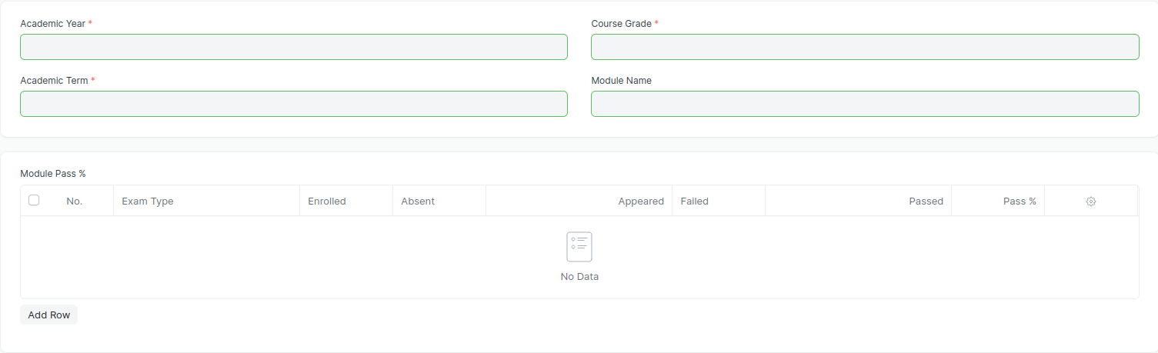

Figure 18 : Module Wise Pass Percentage Screen

### **Field List**

The “Module Wise Pass Percentage” screen shall consist of the following fields:

|  |  |  |  |  |  |  |
| --- | --- | --- | --- | --- | --- | --- |
| **ID** | **Field Label** | **Field Type** | **Validation/Action** | **Mandatory** | **Remarks** | **R/N/D** |
| 1 | Academic Year | Link Field | Fetched from Academic Year master screen | Yes |  | N |
| 2 | Academic Term | Link Field | Fetched from Academic Term master screen | Yes |  | N |
| 3 | Course Grade | Link Field | Fetched from Program Grade master screen | Yes |  | N |
| 4 | Module Name | Link Field | Fetched from Module master screen | Yes |  | N |

|  |  |  |  |  |  |  |
| --- | --- | --- | --- | --- | --- | --- |
| **ID** | **Field Label** | **Field Type** | **Validation/Action** | **Mandatory** | **Remarks** | **R/N/D** |
| 1 | Exam Type | Link Field | Fetched from Exam Type master screen |  |  | N |
| 2 | Enrolled | Number | Calculated based on the number of students enrolled in the selected course |  |  | N |
| 3 | Absent | Number | Calculated based on Exam Attendance |  |  | N |
| 4 | Appeared | Number | Calculated based on Exam Attendance |  |  | N |
| 5 | Failed | Number |  |  |  | N |
| 6 | Pass | Number |  |  |  | N |
| 7 | Pass % | Float |  |  |  | N |

### **User: Roles & Permission**

The following table describes the users and their roles and permissions for the screens :

|  |  |  |  |  |  |  |  |  |
| --- | --- | --- | --- | --- | --- | --- | --- | --- |
| **ID** | **Role** | **Read** | **Write** | **Create** | **Delete** | **Submit** | **Cancel** | **Amend** |
| 1 | Admin | Yes | Yes | Yes | Yes | NA | NA | NA |
| 2 | Instructor | Yes | Yes | Yes | No | NA | NA | NA |
| 3 | Student | Yes | No | No | No | NA | NA | NA |

## Course Wise Pass Percentage

**General Description**

|  |  |
| --- | --- |
| **Description** | Course Pass Percentage is used to calculate the percentage of students who successfully completed any given course during any given Academic Year. The pass percentage for each course in the institute examination is used to assess students' overall performance in that course. |
| **Navigation** |  |
| **Pre-requisites** |  |
| **Existing Screen Name** |  |
| **New Screen Name** |  |

### **Screenshot**

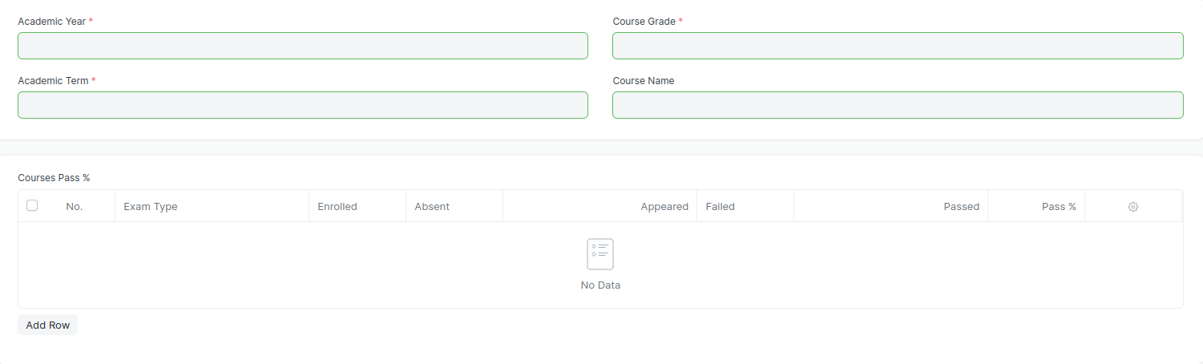

Figure 19 : Course Wise Pass Percentage Screen

### **Field List**

The “Course Wise Pass Percentage” screen shall consist of the following fields:

|  |  |  |  |  |  |  |
| --- | --- | --- | --- | --- | --- | --- |
| **ID** | **Field Label** | **Field Type** | **Validation/Action** | **Mandatory** | **Remarks** | **R/N/D** |
| 1 | Academic Year | Link Field | Fetched from Academic Year master screen | Yes |  | N |
| 2 | Academic Term | Link Field | Fetched from Academic Term master screen | Yes |  | N |
| 3 | Course Grade | Link Field | Fetched from Program Grade master screen | Yes |  | N |
| 4 | Course Name | Link Field | Fetched from Program master screen | Yes |  | N |

|  |  |  |  |  |  |  |
| --- | --- | --- | --- | --- | --- | --- |
| **ID** | **Field Label** | **Field Type** | **Validation/Action** | **Mandatory** | **Remarks** | **R/N/D** |
| 1 | Exam Type | Link Field | Fetched from Exam Type master screen |  |  | N |
| 2 | Enrolled | Number | Calculated based on the number of students enrolled in the selected course |  |  | N |
| 3 | Absent | Number | Calculated based on Exam Attendance |  |  | N |
| 4 | Appeared | Number | Calculated based on Exam Attendance |  |  | N |
| 5 | Failed | Number |  |  |  | N |
| 6 | Pass | Number |  |  |  | N |
| 7 | Pass % | Float |  |  |  | N |

### **User: Roles & Permission**

The following table describes the users and their roles and permissions for the screens :

|  |  |  |  |  |  |  |  |  |
| --- | --- | --- | --- | --- | --- | --- | --- | --- |
| **ID** | **Role** | **Read** | **Write** | **Create** | **Delete** | **Submit** | **Cancel** | **Amend** |
| 1 | Admin | Yes | Yes | Yes | Yes | NA | NA | NA |
| 2 | Instructor | Yes | Yes | Yes | No | NA | NA | NA |
| 3 | Student | Yes | No | No | No | NA | NA | NA |

## Back Paper Tracking

**General Description**

|  |  |
| --- | --- |
| **Description** | Back Paper Tracking is used to actively track and maintain the history of the whole Examination process of a student who has failed in one or more modules. |
| **Navigation** |  |
| **Pre-requisites** | Final Exam Result |
| **Existing Screen Name** |  |
| **New Screen Name** |  |

### **Screenshot**

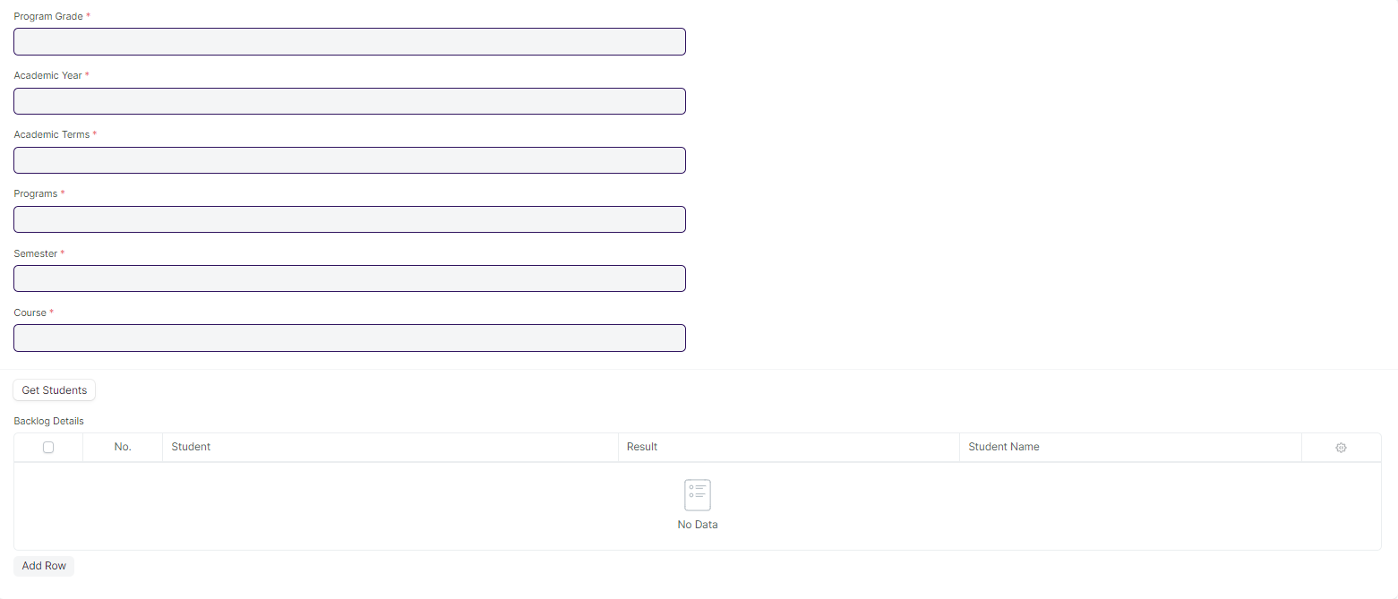

Figure 20 : Back Paper Tracking Screen

### **Field List**

The “Back Paper Tracking Screenshot” screen shall consist of the following fields:

|  |  |  |  |  |  |  |
| --- | --- | --- | --- | --- | --- | --- |
| **ID** | **Field Label** | **Field Type** | **Validation/Action** | **Mandatory** | **Remarks** | **R/N/D** |
| 1 | Program Grade | Link Field | Fetched from Program Grade master screen | Yes |  | ( R ) Course Grade |
| 2 | Academic Year | Text Field | Fetched from Academic Year master screen | Yes |  |  |
| 3 | Academic Term | Link Field | Fetched from the Academic Term master screen,filter will be applied based on Academic Year | Yes |  |  |
| 4 | Programs | Text Field | Fetched from Programs master screen | Yes |  | ( R ) Course |
| 5 | Semester | Link Field | Fetched from Semester master screen,filtered will be applied based on selected programs | Yes |  |  |
| 6 | Course | Text Field | Fetched from Course master screen | Yes |  | ( R ) Module |
| 7 | Get Students | Button |  |  |  |  |
| 8 | **Backlog Details** | Table |  |  | This table is described below |  |

|  |  |  |  |  |  |  |
| --- | --- | --- | --- | --- | --- | --- |
| **Students** | | | | | | |
| **ID** | **Field Label** | **Field Type** | **Validation/Action** | **Mandatory** | **Remarks** | **R/N/D** |
| 1 | Student | Link Field | Failed student will be fetched clicking on Get Student Button |  |  |  |
| 2 | Student Name | Text Field | Auto fetch based on Student |  |  |  |
| 3 | Result | Text Field | Fail |  |  |  |

### **User: Roles & Permission**

The following table describes the users and their roles and permissions for the screens :

|  |  |  |  |  |  |  |  |  |
| --- | --- | --- | --- | --- | --- | --- | --- | --- |
| **ID** | **Role** | **Read** | **Write** | **Create** | **Delete** | **Submit** | **Cancel** | **Amend** |
| 1 | Admin | Yes | Yes | Yes | Yes | NA | NA | NA |
| 2 | Instructor | Yes | Yes | Yes | No | NA | NA | NA |
| 3 | Student | Yes | No | No | No | NA | NA | NA |

## Cumulative Marksheet

**General Description**

|  |  |
| --- | --- |
| **Description** | Cumulative Marksheet is a compilation of all the semesters with their grades in a single certificate. The Cumulative marksheet will have a list of subjects, grades obtained and CGPA (Cumulative Grade Point Average). And also details of students, such as roll number, name, age and date of birth, program enrollment. |
| **Navigation** | Home > Examination > Transcripts > Cumulative Marksheet |
| **Pre-requisites** | Final Exam Result |
| **Existing Screen Name** | Cumulative Marksheet |
| **New Screen Name** | NA |

### **Screenshot**

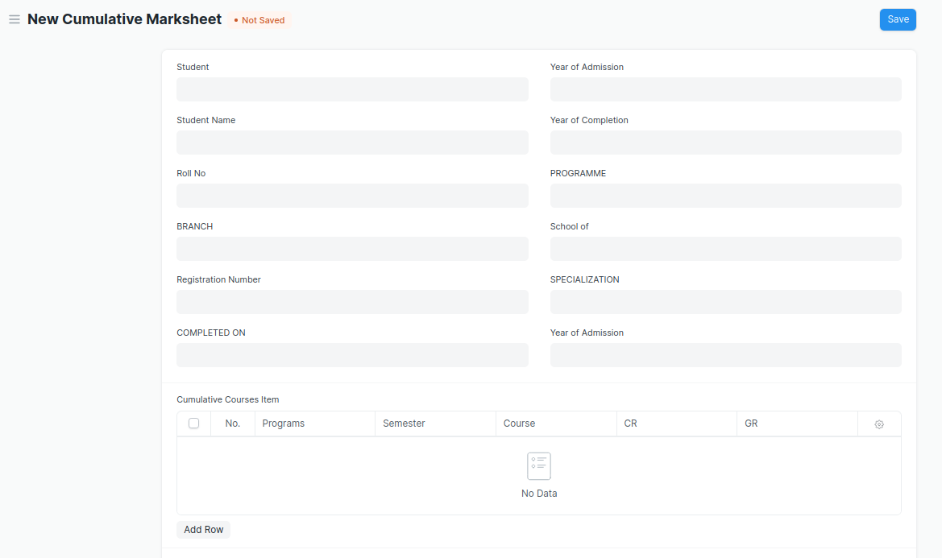

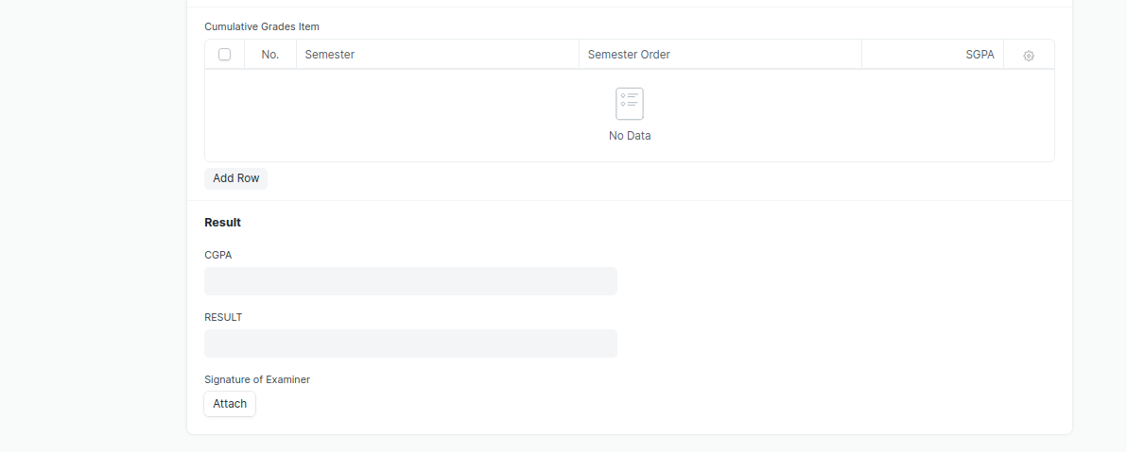

Figure 21 : Cumulative Marksheet Screen

* Remove/Hide the CGPA, SGPA, and Credit features from the Cumulative Mark sheet and display the percentage and grade instead.

### **Field List**

The “Cumulative Marksheet” screen shall consist of the following fields:

|  |  |  |  |  |  |  |
| --- | --- | --- | --- | --- | --- | --- |
| **ID** | **Field Label** | **Field Type** | **Validation/Action** | **Mandatory** | **Remarks** | **R/N/D** |
| 1 | Student | Link Field | Fetched from Student master screen |  |  |  |
| 2 | Student Name | Text Field | Auto fetch based on Student |  |  |  |
| 3 | Roll No | Text Field | Auto fetch based on Student |  |  |  |
| 4 | BRANCH | Text Field |  |  |  |  |
| 5 | Registration Number | Text Field | Auto fetch based on Student |  |  | (D) |
| 6 | COMPLETED ON | Text Field |  |  |  |  |
| 7 | Year of Admission | Link Field | Fetched from Academic Year master screen |  |  |  |
| 8 | Year of Completion | Link Field | Linked with Academic Year master screen |  |  |  |
| 9 | PROGRAMME | Link Field | Fetched from Programs master screen |  |  | (R)COURSE NAME |
| 10 | School of | Text Field |  |  |  |  |
| 11 | Year of Admission | Text Field |  |  |  |  |
| 12 | **Cumulative Courses Item** | Table | Child Table: Cumulative Courses Item |  | These table is describe below |  |
| 13 | **Cumulative Grades Item** | Table | Child Table: Cumulative Grades Item |  | These table is describe below |  |
| 14 | Overall Grade | Float |  |  |  |  |
| 15 | RESULT | Text Field | User Input |  |  |  |
| 16 | Signature of Examiner | Attach image | 1. On attachment, a dialogue box will popup where the user can attach the files, take the picture with the help camera or can link to any URL. 2. If photos or images attached then the size will be maximum 200 kb |  |  |  |

|  |  |  |  |  |  |  |
| --- | --- | --- | --- | --- | --- | --- |
| **Cumulative Courses Item** | | | | | | |
| **ID** | **Field Label** | **Field Type** | **Validation/Action** | **Mandatory** | **Remarks** | **R/N/D** |
| 1 | Programs | Link Field | Fetched from Programs master screen |  |  |  |
| 2 | Semester | Link Field | Fetched from Program master screen |  |  |  |
| 3 | Course | Link Field | Fetched from Course master screen |  |  | (R) Module |
| 4 | Course Code | Text Field | Auto fetch based on Course |  |  | (R) Module Code |
| 5 | Course Name | Text Field | Auto fetch based on Course |  |  | (R) Module Name |
| 6 | CR | Text Field |  |  |  | ( D ) |
| 7 | GR | Text Field |  |  |  | ( D ) |

|  |  |  |  |  |  |  |
| --- | --- | --- | --- | --- | --- | --- |
| **Cumulative Grades Item** | | | | | | |
| **ID** | **Field Label** | **Field Type** | **Validation/Action** | **Mandatory** | **Remarks** | **R/N/D** |
| 1 | Semester | Link Field | Fetched from Program master screen |  |  |  |
| 2 | Semester Order | Drop down | 1ST SEM  2ND SEM  3RD SEM  4TH SEM  5TH SEM  6TH SEM  7TH SEM  8TH SEM  9TH SEM  10TH SEM |  |  |  |
| 3 | Grade | Text Field |  |  |  | (D) These field will be deleted |

Role:

* Remove/Hide the CGPA, SGPA, and Credit features from the Cumulative Mark sheet and display the percentage and grade instead.
* Renaming of labels is required in Cumulative Courses Item child table for Course, Course Name, and Course Code to Module, Module Name, and Module Code respectively.
* Deletion of “Overall grade” Field and “Grade” Field in Cumulative Grades Item child table.

### **User: Roles & Permission**

The following table describes the users and their roles and permissions for the screens :

|  |  |  |  |  |  |  |  |  |
| --- | --- | --- | --- | --- | --- | --- | --- | --- |
| **ID** | **Role** | **Read** | **Write** | **Create** | **Delete** | **Submit** | **Cancel** | **Amend** |
| 1 | Admin | Yes | Yes | Yes | Yes | NA | NA | NA |
| 2 | Instructor | Yes | Yes | Yes | No | NA | NA | NA |
| 3 | Student | Yes | No | No | No | NA | NA | NA |

## Cumulative Marksheet Tool

**General Description**

|  |  |
| --- | --- |
| **Description** | Cumulative Marksheet Tool is a compilation of all the semesters with their grades in a single certificate. The Cumulative marksheet will have a list of subjects, grades obtained and CGPA (Cumulative Grade Point Average). And also details of students, such as roll number, name, age and date of birth, program enrollment. |
| **Navigation** | Home > Examination > Tools > Cumulative Marksheet Tool |
| **Pre-requisites** | Final Exam Result |
| **Existing Screen Name** | Cumulative Marksheet |
| **New Screen Name** | NA |

### **Screenshot**

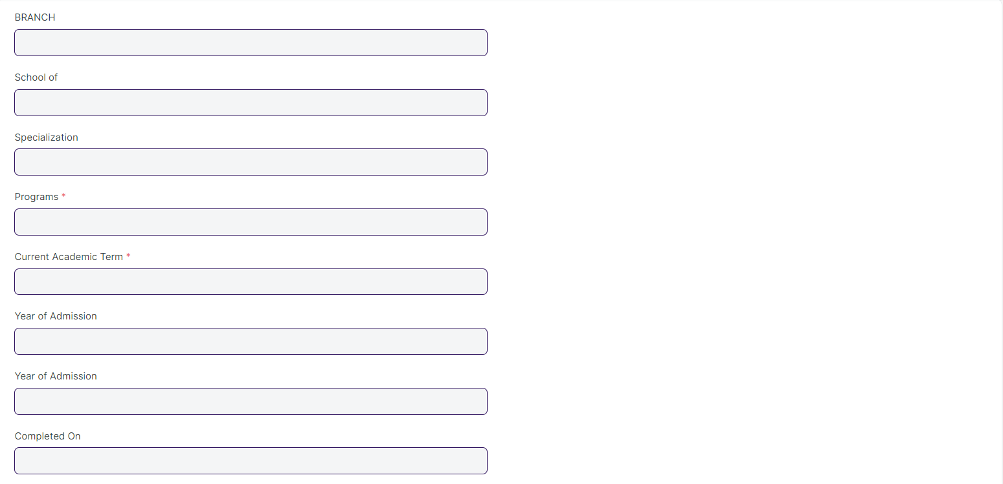

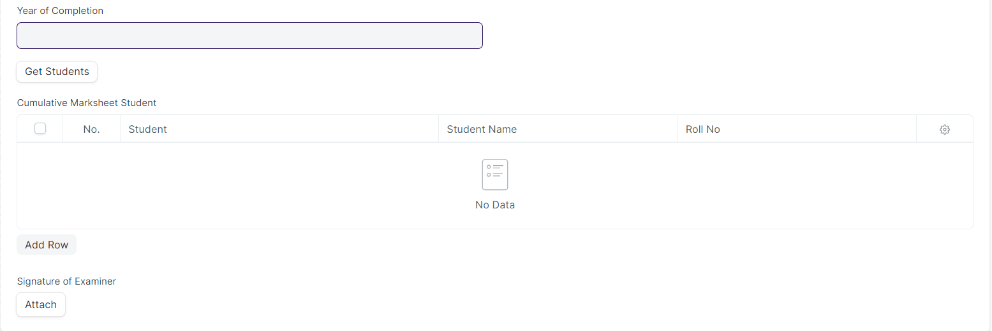

Figure 22 : Cumulative Marksheet Tool

* Remove/Hide the CGPA, SGPA, and Credit features from the Cumulative Mark sheet and display the percentage and grade instead.

### **Field List**

The “Cumulative Marksheet Tool” screen shall consist of the following fields:

|  |  |  |  |  |  |  |
| --- | --- | --- | --- | --- | --- | --- |
| **ID** | **Field Label** | **Field Type** | **Validation/Action** | **Mandatory** | **Remarks** | **R/N/D** |
| 1 | BRANCH | Text Field |  |  |  |  |
| 2 | School of | Text Field |  |  |  |  |
| 3 | Specialization | Text Field |  |  |  |  |
| 4 | Programs | Link Field | Fetched from Programs master screen | Yes |  |  |
| 5 | Current Academic Term | Link Field | Fetched from Academic Term master screen | Yes |  |  |
| 6 | Year of Admission | Link Field | Fetched from Academic Year master screen |  |  |  |
| 7 | COMPLETED ON | Text Field |  |  |  |  |
| 8 | Year of Completion | Link Field | Fetched from Academic Year master screen |  |  |  |
| 9 | Result Creation Status | Dropdown | In Process/Failed/  Successful |  |  |  |
| 10 | Get Students | Button | On click this button Student will fetch based on Programs & Academic Term in the Cumulative Marksheet Student |  |  |  |
| 11 | Total Students for Marksheet | Number |  |  |  |  |
| 12 | **Cumulative Marksheet Student** | Table | Child Table: Cumulative Marksheet Student |  | These table is describe below |  |
| 13 | Signature of Examiner | Attach image | 1. On attachment, a dialogue box will be popup where the user can attach the files, take the picture with the help camera or can link to any URL.   If photos or images attached then the size will be maximum 200 kb |  |  |  |

|  |  |  |  |  |  |  |
| --- | --- | --- | --- | --- | --- | --- |
| **Cumulative Marksheet Student** | | | | | | |
| **ID** | **Field Label** | **Field Type** | **Validation/Action** | **Mandatory** | **Remarks** | **R/N/D** |
| 1 | Student | Link Field | Fetched from “Get Students” Button |  |  |  |
| 2 | Student Name | Text Field | Auto fetch based on Student |  |  |  |
| 3 | Roll No | Text Field | Auto fetch based on Student |  |  |  |
| 4 | Registration Number | Text Field | Auto fetch based on Student |  |  | (D) |

Notes :

* Remove/Hide the CGPA, SGPA, and Credit features from the Cumulative Mark sheet and display the percentage and grade instead

### **User: Roles & Permission**

The following table describes the users and their roles and permissions for the screens :

|  |  |  |  |  |  |  |  |  |
| --- | --- | --- | --- | --- | --- | --- | --- | --- |
| **ID** | **Role** | **Read** | **Write** | **Create** | **Delete** | **Submit** | **Cancel** | **Amend** |
| 1 | Admin | Yes | Yes | Yes | Yes | NA | NA | NA |
| 2 | Instructor | Yes | Yes | Yes | No | NA | NA | NA |
| 3 | Student | Yes | No | No | No | NA | NA | NA |